

ALGORÍTMICA

PRÁCTICA 2: ALGORITMOS DIVIDE Y VENCERÁS

Memoria final de la práctica

Ignacio Aguilera Martos
Luis Balderas Ruiz
Diego Asterio de Zaballa Rodríguez
Miguel Ángel Torres López



ÍNDICE

1. Serie unimodal de números

1.1 Algoritmo Evidente (Código, explicación, gráfica)
1.2 Primera solución DyV (Código, explicación, gráfica)
1.3 Segunda solución DyV (Código, explicación, gráfica)
1.4 Comparación entre algoritmos

2. Comparación de preferencias

2.1 Algoritmo Evidente (Código, explicación, gráfica)
2.2 Solución DyV (Código, explicación, gráfica)
2.3 Comparación entre algoritmos

3. Bibliografía

En lo que sigue, los miembros del grupo combinamos sistemas operativos y maquinas diferentes para experimentar de la forma más completa y variada la eficiencia de los algoritmos. Estas son las prestaciones de las máquinas:

- Luis: Fujitsu. Intel Core i5. Ubuntu 14.04
- Ignacio: Toshiba. Intel Core i7. Ubuntu 14.04
- Diego: Mac. Intel Core i7. OS X El Capitán
- Miguel Ángel: Toshiba. Intel Core i7. Windows 10

1. Serie unimodal de números

Nuestro problema consistía en que se nos daba un vector de números que crecía estrictamente hasta un determinado índice a partir del cual decrecía de manera estricta. Debemos devolver mediante nuestros algoritmos el índice en el que dicho cambio de crecimiento se produce.

1.1 Algoritmo Evidente

En este primer algoritmo que hemos implementado para la resolución de nuestro problema hemos utilizado una versión muy simple que recorre el vector de manera secuencial. Nuestra intención es ir recorriéndolo desde la posición 0 hasta el final. Si nos encontramos un punto en el que el vector en vez de crecer decrece no continuamos avanzando ya que hemos llegado al punto que andábamos buscando, es decir, si v[i]>v[i+1] siendo el índice i el primero con el que ocurre esto.

Presentamos el código:

#include <iostream>
#include <vector>
#include <cstdlib>
#include <cstdio>
#include <ctime>
#include <climits>
#include <cassert>
#include <chrono>

using namespace std;

double uniforme()
{
double u;
u = (double) rand();
u = u/(double)(RAND_MAX+1.0);
return u;
}

int serie_unimodal_secuencial(int *v, int n)
{
int i=0;
int maximo=0;
while(v[i]<v[i+1] && ((i+1)<n))
i++;

//maximo=v[i];
return i;
}

using namespace std::chrono;

int main(int argc, char * argv[])
{
high_resolution_clock::time_point t1, t2;
if (argc != 2)
{
cerr << "Formato " << argv[0] << " <num_elem>" << endl;
return -1;
}

int n = atoi(argv[1]);

int * T = new int[n];
assert(T);

srand(time(0));
double u=uniforme();
int p=1+(int)((n-2)*u);
T[p]=n-1;
for (int i=0; i<p; i++) T[i]=i;
for (int i=p+1; i<n; i++) T[i]=n-1-i+p;

t1=high_resolution_clock::now();
int pos_maximo_secuencial=serie_unimodal_secuencial(T,n);
t2=high_resolution_clock::now();
duration<double> transcurrido = duration_cast<duration<double> >(t2-t1);
cout << n << " " << transcurrido.count() << "\n";

return 0;
}

Vemos que la eficiencia del algoritmo en este caso es lineal comparando entre sí la suma al cuadrado de los residuos de los distintos ajustes realizados.
Lineal = 9.07552e-06
nlogarítmica = 9.73699e-06
logarítmica = 7.55603e-05

Datos:
-Tabla y gŕafica de Nacho(Toshiba,Linux):

Tamaño | Tiempo
1 | 1.27e-07
5001 | 5,90E-003
10001 | 1.1943e-05
15001 | 1.7457e-05
20001 | 2.3192e-05
25001 | 2.8999e-05
30001 | 3.4822e-05
35001 | 4.6544e-05
40001 | 4.6336e-05
45001 | 5.3974e-05
50001 | 5.7989e-05
55001 | 6.3656e-05
60001 | 6.9476e-05
65001 | 7.5713e-05
70001 | 8.1491e-05
75001 | 9.7841e-05
80001 | 9.3249e-05
85001 | 9,90E-002
90001 | 0.000192161
95001 | 0.000202677
100001 | 0.000213223
105001 | 0.000224879
110001 | 0.000234944
115001 | 0.000246068
120001 | 0.000269558
125001 | 0.000289279
130001 | 0.000277595
135001 | 0.000291965
140001 | 0.000311541
145001 | 0.000338547
150001 | 0.000346358
155001 | 0.000335746
160001 | 0.000348103
165001 | 0.000355319
170001 | 0.000366716
175001 | 0.000377835
180001 | 0.000387789
185001 | 0.000523113
190001 | 0.000566678
195001 | 0.000578435
200001 | 0.000590914
205001 | 0.000500872
210001 | 0.0004561
215001 | 0.000485209
220001 | 0.000505239
225001 | 0.000472726
230001 | 0.000496295
235001 | 0.000506936
240001 | 0.000628285
245001 | 0.000527266
250001 | 0.000596488
255001 | 0.000784005
260001 | 0.000766952
265001 | 0.000781397
270001 | 0.000581821
275001 | 0.000665732
280001 | 0.000651741
285001 | 0.000621775
290001 | 0.000625208
295001 | 0.000639049
300001 | 0.000646797
305001 | 0.00080322
310001 | 0.000674393
315001 | 0.000697023
320001 | 0.000694685
325001 | 0.000700247
330001 | 0.000737563
335001 | 0.00081823
340001 | 0.000856715
345001 | 0.000737018
350001 | 0.00107456
355001 | 0.00135471
360001 | 0.00121005
365001 | 0.001119
370001 | 0.00113662
375001 | 0.0011993
380001 | 0.00116807
385001 | 0.00127384
390001 | 0.00123833
395001 | 0.00123346
400001 | 0.00122626
405001 | 0.00124616
410001 | 0.00128398
415001 | 0.00128159
420001 | 0.00131595
425001 | 0.00135981
430001 | 0.00132351
435001 | 0.0013351
440001 | 0.00137901
445001 | 0.00139873
450001 | 0.00132308
455001 | 0.00134034
460001 | 0.00143829
465001 | 0.0013664
470001 | 0.00138172
475001 | 0.00145137
480001 | 0.0014284
485001 | 0.00149353
490001 | 0.00150792
495001 | 0.00149775
500001 | 0.00106973
505001 | 0.0010926
510001 | 0.00120486
515001 | 0.00111586
520001 | 0.00111548
525001 | 0.00112312
530001 | 0.00115674
535001 | 0.00118471
540001 | 0.00112244
545001 | 0.0011931
550001 | 0.00124476
555001 | 0.00119023
560001 | 0.0012001
565001 | 0.00153581
570001 | 0.00123661
575001 | 0.00125888
580001 | 0.00126255
585001 | 0.00130891
590001 | 0.0013715
595001 | 0.00127158
600001 | 0.00184235
605001 | 0.0028676
610001 | 0.00241481
615001 | 0.00136257
620001 | 0.00133047
625001 | 0.00157993
630001 | 0.00160256
635001 | 0.00224412
640001 | 0.00227042
645001 | 0.00264473
650001 | 0.00139233
655001 | 0.00141823
660001 | 0.00151978
665001 | 0.00269443
670001 | 0.00198452
675001 | 0.00232555
680001 | 0.00278734
685001 | 0.0021844
690001 | 0.00206358
695001 | 0.00203935
700001 | 0.00210445
705001 | 0.00213257
710001 | 0.0020844
715001 | 0.00258757
720001 | 0.00153732
725001 | 0.00163313
730001 | 0.00155058
735001 | 0.00245493
740001 | 0.00157173
745001 | 0.00164656
750001 | 0.00156051
755001 | 0.00297318
760001 | 0.00362019
765001 | 0.00415503
770001 | 0.00172869
775001 | 0.00177365
780001 | 0.00166782
785001 | 0.00171216
790001 | 0.0018537
795001 | 0.00244351
800001 | 0.00455048
805001 | 0.00419158
810001 | 0.00389429
815001 | 0.0041388
820001 | 0.00363567
825001 | 0.00179199
830001 | 0.00182496
835001 | 0.00328139
840001 | 0.00332854
845001 | 0.00205908
850001 | 0.00182589
855001 | 0.00177933
860001 | 0.00185662
865001 | 0.00441101
870001 | 0.00201723
875001 | 0.0019275
880001 | 0.00185379
885001 | 0.00225509
890001 | 0.00196903
895001 | 0.00190935
900001 | 0.00193913
905001 | 0.00193483
910001 | 0.00194731
915001 | 0.00293374
920001 | 0.00469932
925001 | 0.00192188
930001 | 0.00201045
935001 | 0.00224927
940001 | 0.00204386
945001 | 0.00213312
950001 | 0.00332134
955001 | 0.00205959
960001 | 0.00328309
965001 | 0.00209894
970001 | 0.00223038
975001 | 0.00210922
980001 | 0.00221177
985001 | 0.00331399
990001 | 0.00222124
995001 | 0.00212957
1000001 | 0.00221753
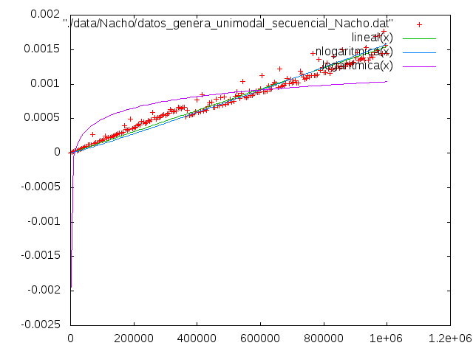

-Tabla y gŕafica de Luis(Fujitsu,Linux):

Tamaño | Tiempo
1 | 1.65e-07
5001 | 8,93E-003
10001 | 1,42E-002
15001 | 2.2072e-05
20001 | 2,93E-002
25001 | 7.3206e-05
30001 | 4.3995e-05
35001 | 8.1913e-05
40001 | 5.8538e-05
45001 | 0.000131739
50001 | 7.3047e-05
55001 | 0.000109569
60001 | 8.7776e-05
65001 | 9.5069e-05
70001 | 0.000102334
75001 | 0.000109621
80001 | 0.000166209
85001 | 0.000149099
90001 | 0.000168333
95001 | 0.000231621
100001 | 0.000153719
105001 | 0.000159431
110001 | 0.000210312
115001 | 0.000176271
120001 | 0.000198383
125001 | 0.000240096
130001 | 0.000190838
135001 | 0.000212365
140001 | 0.000244785
145001 | 0.000213011
150001 | 0.000228014
155001 | 0.000234689
160001 | 0.000248774
165001 | 0.000280106
170001 | 0.000296496
175001 | 0.000258078
180001 | 0.000264963
185001 | 0.000262612
190001 | 0.00026995
195001 | 0.000356971
200001 | 0.000294089
205001 | 0.000301725
210001 | 0.000308938
215001 | 0.000315664
220001 | 0.00034824
225001 | 0.0003289
230001 | 0.000354303
235001 | 0.000654191
240001 | 0.000627257
245001 | 0.000615984
250001 | 0.000628281
255001 | 0.000673397
260001 | 0.000729668
265001 | 0.000966332
270001 | 0.00131237
275001 | 0.00117727
280001 | 0.000782564
285001 | 0.0007658
290001 | 0.000808406
295001 | 0.000836961
300001 | 0.000780479
305001 | 0.000950285
310001 | 0.000810363
315001 | 0.000792879
320001 | 0.00095634
325001 | 0.000883486
330001 | 0.000941352
335001 | 0.000935697
340001 | 0.000883123
345001 | 0.00092245
350001 | 0.000982877
355001 | 0.00089432
360001 | 0.00100362
365001 | 0.000950843
370001 | 0.000961586
375001 | 0.000943435
380001 | 0.000982561
385001 | 0.000997226
390001 | 0.00103753
395001 | 0.00119681
400001 | 0.00110818
405001 | 0.00104414
410001 | 0.00106905
415001 | 0.00125756
420001 | 0.00108333
425001 | 0.00110324
430001 | 0.00112414
435001 | 0.00117496
440001 | 0.00117137
445001 | 0.00111849
450001 | 0.00113079
455001 | 0.00123885
460001 | 0.00120047
465001 | 0.0011865
470001 | 0.00124812
475001 | 0.00152137
480001 | 0.00129417
485001 | 0.00125638
490001 | 0.0012734
495001 | 0.00133921
500001 | 0.0012837
505001 | 0.00128129
510001 | 0.00135213
515001 | 0.00133157
520001 | 0.00137378
525001 | 0.00135834
530001 | 0.0014917
535001 | 0.00140768
540001 | 0.00146108
545001 | 0.0014126
550001 | 0.00138364
555001 | 0.00139476
560001 | 0.00140883
565001 | 0.00162786
570001 | 0.00159838
575001 | 0.0014476
580001 | 0.00244171
585001 | 0.00286447
590001 | 0.00227871
595001 | 0.00217518
600001 | 0.00204661
605001 | 0.00188058
610001 | 0.00187855
615001 | 0.00177752
620001 | 0.00205222
625001 | 0.00165675
630001 | 0.00180923
635001 | 0.00173059
640001 | 0.00166831
645001 | 0.00169786
650001 | 0.00182026
655001 | 0.00164627
660001 | 0.00172811
665001 | 0.00194293
670001 | 0.00169218
675001 | 0.00171823
680001 | 0.0018487
685001 | 0.00179305
690001 | 0.00177858
695001 | 0.00192259
700001 | 0.00182309
705001 | 0.00205372
710001 | 0.00204714
715001 | 0.00188209
720001 | 0.00183284
725001 | 0.00206286
730001 | 0.0020021
735001 | 0.00191744
740001 | 0.00221491
745001 | 0.00187354
750001 | 0.00198633
755001 | 0.00205921
760001 | 0.00195037
765001 | 0.00202878
770001 | 0.00206821
775001 | 0.00194542
780001 | 0.00200215
785001 | 0.00219116
790001 | 0.00202818
795001 | 0.00252695
800001 | 0.00239506
805001 | 0.00230549
810001 | 0.00251272
815001 | 0.0022299
820001 | 0.00215939
825001 | 0.00215938
830001 | 0.00222084
835001 | 0.00210033
840001 | 0.00217242
845001 | 0.00237756
850001 | 0.00231043
855001 | 0.00225258
860001 | 0.00361198
865001 | 0.002218
870001 | 0.00239355
875001 | 0.00226665
880001 | 0.0025828
885001 | 0.00265594
890001 | 0.00225736
895001 | 0.00243189
900001 | 0.00257167
905001 | 0.00241975
910001 | 0.00229155
915001 | 0.00256359
920001 | 0.00240987
925001 | 0.00233638
930001 | 0.00242957
935001 | 0.00324645
940001 | 0.00239077
945001 | 0.00237946
950001 | 0.00312879
955001 | 0.00246237
960001 | 0.0025721
965001 | 0.00248514
970001 | 0.00244678
975001 | 0.00254417
980001 | 0.00256283
985001 | 0.00263438
990001 | 0.00259345
995001 | 0.00278291
1000001 | 0.00255994

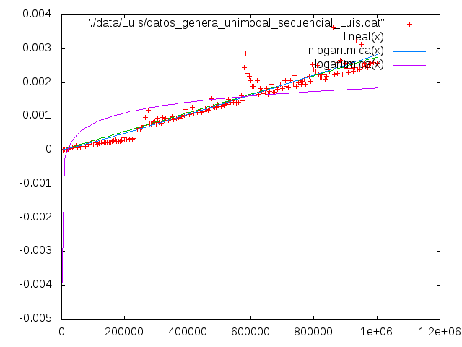

-Tabla y gŕafica de Miguel(Toshiba,Windows):

Tamaño | Tiempo
1 | 0
5001 | 2.0955e-005
10001 | 4.14824e-005
15001 | 6.20098e-005
20001 | 8.21096e-005
25001 | 7.22735e-005
30001 | 8.63861e-005
35001 | 0.000100926
40001 | 0.000115039
45001 | 0.00013129
50001 | 0.000144547
55001 | 0.000158232
60001 | 0.0001732
65001 | 0.000188168
70001 | 0.000202708
75001 | 0.000216821
80001 | 0.000230505
85001 | 0.000244618
90001 | 0.000260441
95001 | 0.000273699
100001 | 0.000289522
105001 | 0.000308766
110001 | 0.000328438
115001 | 0.000379329
120001 | 0.00041012
125001 | 0.000360085
130001 | 0.000374197
135001 | 0.000388737
140001 | 0.000404133
145001 | 0.00041739
150001 | 0.000431503
155001 | 0.000449037
160001 | 0.000461011
165001 | 0.000475124
170001 | 0.00049223
175001 | 0.00050677
180001 | 0.000608552
185001 | 0.000611545
190001 | 0.000546969
195001 | 0.000561082
200001 | 0.000579044
205001 | 0.000591018
210001 | 0.000629934
215001 | 0.000618388
220001 | 0.000637204
225001 | 0.000649179
230001 | 0.000663719
235001 | 0.000715037
240001 | 0.000715893
245001 | 0.00095153
250001 | 0.000719742
255001 | 0.000735565
260001 | 0.000748394
265001 | 0.000764645
270001 | 0.00077662
275001 | 0.000791588
280001 | 0.000807411
285001 | 0.000847183
290001 | 0.000976334
295001 | 0.000849748
300001 | 0.000916462
305001 | 0.000886527
310001 | 0.000894652
315001 | 0.000912186
320001 | 0.000928864
325001 | 0.000942977
330001 | 0.00106272
335001 | 0.000963932
340001 | 0.000988308
345001 | 0.00102637
350001 | 0.00100798
355001 | 0.0010315
360001 | 0.00103749
365001 | 0.00125174
370001 | 0.00106785
375001 | 0.00109565
380001 | 0.00109351
385001 | 0.00110976
390001 | 0.00112687
395001 | 0.00115167
400001 | 0.00115467
405001 | 0.00123164
410001 | 0.00121924
415001 | 0.00119786
420001 | 0.00121283
425001 | 0.00134925
430001 | 0.00124191
435001 | 0.00127612
440001 | 0.00128125
445001 | 0.00132701
450001 | 0.00129451
455001 | 0.00139928
460001 | 0.00141639
465001 | 0.00135566
470001 | 0.00135994
475001 | 0.00138432
480001 | 0.00138517
485001 | 0.00140185
490001 | 0.00143264
495001 | 0.00146899
500001 | 0.00144462
505001 | 0.00147412
510001 | 0.00160883
515001 | 0.00150534
520001 | 0.00150449
525001 | 0.00151561
530001 | 0.0015464
535001 | 0.00161824
540001 | 0.00156136
545001 | 0.00162295
550001 | 0.00158959
555001 | 0.00159943
560001 | 0.00188039
565001 | 0.00188382
570001 | 0.0019052
575001 | 0.00208952
580001 | 0.00167427
585001 | 0.00169351
590001 | 0.00173371
595001 | 0.0017196
600001 | 0.00177647
605001 | 0.00182608
610001 | 0.00176322
615001 | 0.00179829
620001 | 0.0021464
625001 | 0.00187141
630001 | 0.00195096
635001 | 0.00183506
640001 | 0.00224818
645001 | 0.0018697
650001 | 0.0018774
655001 | 0.00189622
660001 | 0.00193428
665001 | 0.00195566
670001 | 0.00194412
675001 | 0.00197833
680001 | 0.0021387
685001 | 0.00205146
690001 | 0.00214554
695001 | 0.0020459
700001 | 0.00205531
705001 | 0.00210449
710001 | 0.00205787
715001 | 0.0021558
720001 | 0.00208481
725001 | 0.00237605
730001 | 0.00212287
735001 | 0.00216222
740001 | 0.00221268
745001 | 0.00216393
750001 | 0.00223663
755001 | 0.00218959
760001 | 0.0025702
765001 | 0.00225288
770001 | 0.00224091
775001 | 0.00225203
780001 | 0.00226186
785001 | 0.00243335
790001 | 0.00228966
795001 | 0.00239401
800001 | 0.00253128
805001 | 0.00233927
810001 | 0.0023444
815001 | 0.00239999
820001 | 0.00238161
825001 | 0.00244661
830001 | 0.0024094
835001 | 0.00242565
840001 | 0.00280284
845001 | 0.00246371
850001 | 0.00246927
855001 | 0.00271175
860001 | 0.00254198
865001 | 0.0025176
870001 | 0.00257106
875001 | 0.00254411
880001 | 0.00255309
885001 | 0.00273399
890001 | 0.00259201
895001 | 0.00259201
900001 | 0.00261468
905001 | 0.00263905
910001 | 0.00272544
915001 | 0.00278531
920001 | 0.00275495
925001 | 0.00268481
930001 | 0.00323349
935001 | 0.00271945
940001 | 0.00273314
945001 | 0.00274853
950001 | 0.00281952
955001 | 0.00300726
960001 | 0.00279942
965001 | 0.00280755
970001 | 0.00282936
975001 | 0.00284048
980001 | 0.00288153
985001 | 0.00286656
990001 | 0.00288196
995001 | 0.00290634
1000001 | 0.00290078

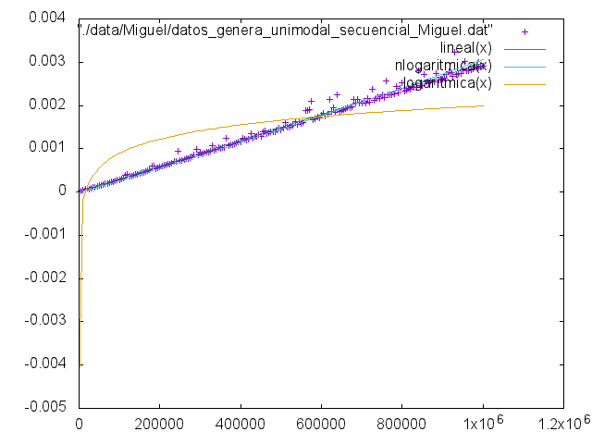
-Tabla y gŕafica de Diego(MacBook Pro,MacOS El Capitán):

Tamaño | Tiempo
1 | 1.46e-07
5001 | 3,36E-003
10001 | 8,49E-003
15001 | 9,62E-003
20001 | 1,55E-002
25001 | 1.5962e-05
30001 | 1.9068e-05
35001 | 2.2213e-05
40001 | 2.5339e-05
45001 | 2,87E-002
50001 | 3.1768e-05
55001 | 4,70E-002
60001 | 3.7973e-05
65001 | 4.1143e-05
70001 | 5,07E-002
75001 | 4.7415e-05
80001 | 5.0665e-05
85001 | 5.3868e-05
90001 | 5.6742e-05
95001 | 6.0481e-05
100001 | 6,32E-002
105001 | 6.6451e-05
110001 | 7.0348e-05
115001 | 8.8778e-05
120001 | 7.6379e-05
125001 | 9.0963e-05
130001 | 9.1459e-05
135001 | 0.000107813
140001 | 9.1485e-05
145001 | 9.2429e-05
150001 | 9,54E-002
155001 | 9,82E-002
160001 | 0.000104178
165001 | 0.000105868
170001 | 0.000110005
175001 | 0.000134818
180001 | 0.000120587
185001 | 0.000117758
190001 | 0.000120811
195001 | 0.000128354
200001 | 0.000126392
205001 | 0.000126681
210001 | 0.000133319
215001 | 0.000160284
220001 | 0.00013935
225001 | 0.000145601
230001 | 0.000145432
235001 | 0.000148843
240001 | 0.00017237
245001 | 0.000163304
250001 | 0.000158448
255001 | 0.000161332
260001 | 0.000165799
265001 | 0.000167015
270001 | 0.000180577
275001 | 0.000174203
280001 | 0.000177898
285001 | 0.000181299
290001 | 0.000203045
295001 | 0.000189335
300001 | 0.000243855
305001 | 0.000209938
310001 | 0.000197697
315001 | 0.00020097
320001 | 0.000201959
325001 | 0.000217791
330001 | 0.000209303
335001 | 0.000226739
340001 | 0.00021565
345001 | 0.000227974
350001 | 0.000236384
355001 | 0.000224983
360001 | 0.000227792
365001 | 0.000231807
370001 | 0.000222246
375001 | 0.000239658
380001 | 0.000261648
385001 | 0.000255104
390001 | 0.00025941
395001 | 0.000249444
400001 | 0.000260502
405001 | 0.000278876
410001 | 0.000270764
415001 | 0.000273193
420001 | 0.000267023
425001 | 0.000268917
430001 | 0.000271674
435001 | 0.00029611
440001 | 0.000279738
445001 | 0.000282297
450001 | 0.000287967
455001 | 0.000323654
460001 | 0.000301068
465001 | 0.000320741
470001 | 0.000296488
475001 | 0.000301187
480001 | 0.000303277
485001 | 0.000308092
490001 | 0.000360423
495001 | 0.000338067
500001 | 0.000316215
505001 | 0.000351308
510001 | 0.000317327
515001 | 0.000354469
520001 | 0.000360321
525001 | 0.000337517
530001 | 0.000337848
535001 | 0.000356139
540001 | 0.000340637
545001 | 0.000351936
550001 | 0.000381576
555001 | 0.00131066
560001 | 0.00036644
565001 | 0.000366209
570001 | 0.000378712
575001 | 0.00040349
580001 | 0.000367093
585001 | 0.000384168
590001 | 0.000390739
595001 | 0.000380573
600001 | 0.000385717
605001 | 0.000400861
610001 | 0.000388419
615001 | 0.000403319
620001 | 0.000405218
625001 | 0.000417977
630001 | 0.00144584
635001 | 0.000432179
640001 | 0.000422046
645001 | 0.000433095
650001 | 0.000400294
655001 | 0.000447429
660001 | 0.000416906
665001 | 0.000420302
670001 | 0.000444847
675001 | 0.000433178
680001 | 0.000453603
685001 | 0.000436862
690001 | 0.000458462
695001 | 0.000457254
700001 | 0.000468636
705001 | 0.000449562
710001 | 0.000449301
715001 | 0.000460481
720001 | 0.000459029
725001 | 0.00047007
730001 | 0.000526514
735001 | 0.000483886
740001 | 0.000614908
745001 | 0.000475854
750001 | 0.000486656
755001 | 0.000488968
760001 | 0.000480878
765001 | 0.000490991
770001 | 0.000494276
775001 | 0.000528421
780001 | 0.000495862
785001 | 0.000500321
790001 | 0.000502949
795001 | 0.000509235
800001 | 0.000511808
805001 | 0.000512701
810001 | 0.000618346
815001 | 0.000515731
820001 | 0.000535681
825001 | 0.00052634
830001 | 0.000525296
835001 | 0.000546462
840001 | 0.000548839
845001 | 0.000553154
850001 | 0.000536715
855001 | 0.000545815
860001 | 0.000540395
865001 | 0.000578994
870001 | 0.000566133
875001 | 0.000554675
880001 | 0.000561063
885001 | 0.000559228
890001 | 0.000570502
895001 | 0.000580354
900001 | 0.000571243
905001 | 0.000572548
910001 | 0.000577582
915001 | 0.000602889
920001 | 0.000596908
925001 | 0.000595489
930001 | 0.000591235
935001 | 0.000605916
940001 | 0.000790384
945001 | 0.000597289
950001 | 0.00061543
955001 | 0.000671175
960001 | 0.000611545
965001 | 0.000627043
970001 | 0.000617976
975001 | 0.000631645
980001 | 0.000621345
985001 | 0.000625939
990001 | 0.000632142
995001 | 0.000655101
1000001 | 0.000671709

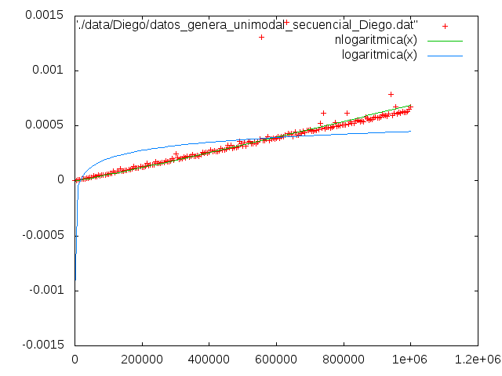

1.2 Primera Solución DyV

En esta primera solución en la que empleamos DyV. Comenzamos presentando el código:

#include <iostream>
#include <vector>
#include <cstdlib>
#include <cstdio>
#include <ctime>
#include <climits>
#include <cassert>
#include <chrono>

using namespace std;

int& buscaPuntoDeCambio(int* v, int indice1, int indice2, int& res)
{
int indi=(indice1+indice2)/2;
if(v[indice1]>v[indice1+1])
{
res=indice1;
return res;
}
else if(v[indice2]>v[indice2-1])
{
res=indice2;
return res;
}
else if(v[indi]-v[indi-1]>0 && v[indi]-v[indi+1]>0)
{
res=indi;
return res;
}
else
{
buscaPuntoDeCambio(v, indice1, indi, res);
buscaPuntoDeCambio(v, indi, indice2, res);
}

}

double uniforme()
{
double u;
u = (double) rand();
u = u/(double)(RAND_MAX+1.0);
return u;
}

using namespace std::chrono;

int main(int argc, char* argv[])
{
high_resolution_clock::time_point t1, t2;
if(argc<2)
{
cout << "Falta el numero de componentes.\n";
exit(1);
}
int n = atoi(argv[1]);

int * T = new int[n];
assert(T);

srand(time(0));
double u=uniforme();
int p=1+(int)((n-2)*u);
T[p]=n-1;
for (int i=0; i<p; i++) T[i]=i;
for (int i=p+1; i<n; i++) T[i]=n-1-i+p;

int res=0;
t1=high_resolution_clock::now();
buscaPuntoDeCambio(T,0,n-1, res);
t2=high_resolution_clock::now();
int punto_cambio=res;
duration<double> transcurrido = duration_cast<duration<double> >(t2-t1);
cout << n << " " << transcurrido.count() << "\n";

return 0;
}

En esta implementación el método que seguimos para obtener el punto de cambio es:
1) Obtenemos el punto medio del vector.
2) Comprobamos si los extremos son el punto que andamos buscando. Si el extremo izquierdo fuera este punto entonces el vector decrecería a partir de dicho punto. Si el extremo derecho fuera el punto entonces el vector crecería hasta dicho extremo.
3) Comprobamos si el punto de cambio es el propio punto medio mediante la comprobación del elemento que antecede al punto medio y el elemento que precede al mismo.
4) Si ninguna de estas comprobaciones nos otorga el punto entonces llamamos recursivamente al algoritmo para una sola de las partes del vector. Si a la derecha del punto medio el vector sigue creciendo descartamos la parte izquierda, si a la izquierda del punto medio el vector decrece descartamos la parte derecha.

Vemos que la eficiencia de dicho algoritmo es logarítmica, lo cual es confirmado al ajustar la función a los datos obtenidos. Lo observamos en este caso con la suma al cuadrado de los residuos obtenida en los ajustes.
Lineal = 2.85144e-10
nlogarítmica = 3.7745e-10
logarítmica = 2.42327e-10

Datos:
-Tabla y gŕafica de Nacho(Toshiba,Linux):

Tamaño | Tiempo
10000 | 7.36e-07
20000 | 6.27e-07
30000 | 6.12e-07
40000 | 8.56e-07
50000 | 7.62e-07
60000 | 6.61e-07
70000 | 9.82e-07
80000 | 8.24e-07
90000 | 7.98e-07
100000 | 7.25e-07
110000 | 7.54e-07
120000 | 5.34e-07
130000 | 9.76e-07
140000 | 1,27E-003
150000 | 8.12e-07
160000 | 6.92e-07
170000 | 9.05e-07
180000 | 7.45e-07
190000 | 7.69e-07
200000 | 9.82e-07
210000 | 7.07e-07
220000 | 5,25E-003
230000 | 1,25E-003
240000 | 1,09E-003
250000 | 7.46e-07
260000 | 6.09e-07
270000 | 7.91e-07
280000 | 7.34e-07
290000 | 7,71E-003
300000 | 7.38e-07
310000 | 1,11E-003
320000 | 9.39e-07
330000 | 1,44E-003
340000 | 1,14E-003
350000 | 9.78e-07
360000 | 7,04E-003
370000 | 9.27e-07
380000 | 9.86e-07
390000 | 1,09E-003
400000 | 2,12E-003
410000 | 1,40E-003
420000 | 1,21E-003
430000 | 7.75e-07
440000 | 8.51e-07
450000 | 1,57E-003
460000 | 1,31E-003
470000 | 5,00E-006
480000 | 1,28E-003
490000 | 1.49e-06
500000 | 1,24E-003
510000 | 1,72E-003
520000 | 1.17e-06
530000 | 1,48E-003
540000 | 1,80E-003
550000 | 1,58E-003
560000 | 1,20E-003
570000 | 1,64E-003
580000 | 1,55E-003
590000 | 1,33E-003
600000 | 1,89E-003
610000 | 1,67E-003
620000 | 1,66E-003
630000 | 1,49E-003
640000 | 2,04E-003
650000 | 1,24E-003
660000 | 2,00E-003
670000 | 1,30E-003
680000 | 2,58E-003
690000 | 1,53E-003
700000 | 1,62E-003
710000 | 1.33e-06
720000 | 1,51E-003
730000 | 1,43E-003
740000 | 1,12E-003
750000 | 1,93E-003
760000 | 1.03e-06
770000 | 1,26E-003
780000 | 1,94E-003
790000 | 1,36E-003
800000 | 1,09E-003
810000 | 1,51E-003
820000 | 1,48E-003
830000 | 1,36E-003
840000 | 8.07e-07
850000 | 1,73E-003
860000 | 5,06E-003
870000 | 9.55e-07
880000 | 1,42E-003
890000 | 1,26E-003
900000 | 1,08E-003
910000 | 1,40E-003
920000 | 1,13E-003
930000 | 1,16E-003
940000 | 2.35e-06
950000 | 1,29E-003
960000 | 8.61e-07
970000 | 4,00E-003
980000 | 1,33E-003
990000 | 1,33E-003
1000000 | 9.71e-07
1010000 | 1,60E-003
1020000 | 1.58e-06
1030000 | 1,90E-003
1040000 | 1,61E-003
1050000 | 1,12E-003
1060000 | 4,15E-003
1070000 | 1,25E-003
1080000 | 1,39E-003
1090000 | 1,70E-003
1100000 | 8.77e-07
1110000 | 1,05E-003
1120000 | 2,05E-003
1130000 | 1,19E-003
1140000 | 9.06e-07
1150000 | 1,34E-003
1160000 | 1,38E-003
1170000 | 1,59E-003
1180000 | 1,29E-003
1190000 | 8.55e-07
1200000 | 1,05E-003
1210000 | 1.06e-06
1220000 | 1,07E-003
1230000 | 9.1e-07
1240000 | 1,19E-003
1250000 | 8.73e-07
1260000 | 9.25e-07
1270000 | 1,61E-003
1280000 | 1,23E-003
1290000 | 1,87E-003
1300000 | 1,32E-003
1310000 | 1,12E-003
1320000 | 1,16E-003
1330000 | 1,43E-003
1340000 | 1,69E-003
1350000 | 1,56E-003
1360000 | 1.45e-06
1370000 | 1,29E-003
1380000 | 1,08E-003
1390000 | 1,23E-003
1400000 | 8.36e-07
1410000 | 9.96e-07
1420000 | 1,34E-003
1430000 | 1,21E-003
1440000 | 1,10E-003
1450000 | 1,01E-003
1460000 | 1,31E-003
1470000 | 1,20E-003
1480000 | 1,09E-003
1490000 | 2.41e-06
1500000 | 1,91E-003
1510000 | 2,09E-003
1520000 | 1.7e-06
1530000 | 1,44E-003
1540000 | 1,11E-003
1550000 | 1,18E-003
1560000 | 9.82e-07
1570000 | 3,18E-003
1580000 | 8.8e-07
1590000 | 9.01e-07
1600000 | 1,36E-003
1610000 | 1,24E-003
1620000 | 3,42E-003
1630000 | 1,26E-003
1640000 | 1,16E-003
1650000 | 1,04E-003
1660000 | 1,16E-003
1670000 | 1,06E-003
1680000 | 1,41E-003
1690000 | 1,99E-003
1700000 | 1,08E-003
1710000 | 1,06E-003
1720000 | 1,61E-003
1730000 | 1,70E-003
1740000 | 1,46E-003
1750000 | 1,33E-003
1760000 | 1,72E-003
1770000 | 1,43E-003
1780000 | 1,48E-003
1790000 | 1,59E-003
1800000 | 1,17E-003
1810000 | 2,18E-003
1820000 | 1,03E-003
1830000 | 9.69e-07
1840000 | 9.58e-07
1850000 | 1,15E-003
1860000 | 2,10E-003
1870000 | 8.73e-07
1880000 | 2,18E-003
1890000 | 1,99E-003
1900000 | 1,28E-003
1910000 | 1,37E-003
1920000 | 1,16E-003
1930000 | 1.74e-06
1940000 | 1,04E-003
1950000 | 2,90E-003
1960000 | 1,05E-003
1970000 | 1,59E-003
1980000 | 1,58E-003
1990000 | 1,47E-003
2000000 | 1,43E-003
2010000 | 1.52e-06
2020000 | 2,39E-003
2030000 | 1,39E-003
2040000 | 2,14E-003
2050000 | 1,30E-003
2060000 | 1,58E-003
2070000 | 3,51E-003
2080000 | 1,23E-003
2090000 | 1,84E-003
2100000 | 2,21E-003
2110000 | 1,38E-003
2120000 | 1,40E-003
2130000 | 2,07E-003
2140000 | 2,19E-003
2150000 | 1,36E-003
2160000 | 1,81E-003
2170000 | 1,49E-003
2180000 | 1,31E-003
2190000 | 1.98e-06
2200000 | 1,26E-003
2210000 | 1,87E-003
2220000 | 1,17E-003
2230000 | 1,31E-003
2240000 | 1,11E-003
2250000 | 1.77e-06
2260000 | 2,18E-003
2270000 | 1,90E-003
2280000 | 2,18E-003
2290000 | 1,02E-003
2300000 | 2,27E-003
2310000 | 9.21e-07
2320000 | 1,43E-003
2330000 | 1,36E-003
2340000 | 2,03E-003
2350000 | 1,83E-003
2360000 | 2.57e-06
2370000 | 3,33E-003
2380000 | 3,09E-003
2390000 | 1,43E-003
2400000 | 4,36E-003
2410000 | 1,80E-003
2420000 | 3,48E-003
2430000 | 2,19E-003
2440000 | 1,71E-003
2450000 | 1,66E-003
2460000 | 1,38E-003
2470000 | 2,60E-003
2480000 | 2,01E-003
2490000 | 2,37E-003
2500000 | 1,42E-003
2510000 | 2,23E-003
2520000 | 1,54E-003
2530000 | 1,37E-003
2540000 | 2,45E-003
2550000 | 1,52E-003
2560000 | 2,13E-003
2570000 | 1,32E-003
2580000 | 2.7e-06
2590000 | 1,63E-003
2600000 | 1,51E-003
2610000 | 2,06E-003
2620000 | 1,79E-003
2630000 | 2,74E-003
2640000 | 1.69e-06
2650000 | 1,47E-003
2660000 | 1,71E-003
2670000 | 1.98e-06
2680000 | 2,02E-003
2690000 | 1,51E-003
2700000 | 1,84E-003
2710000 | 2,34E-003
2720000 | 1,70E-003
2730000 | 1,48E-003
2740000 | 2,22E-003
2750000 | 1,64E-003
2760000 | 1,30E-003
2770000 | 2,37E-003
2780000 | 5.36e-06
2790000 | 1,35E-003
2800000 | 1,42E-003
2810000 | 1.1669e-05
2820000 | 1,83E-003
2830000 | 1,58E-003
2840000 | 1.0257e-05
2850000 | 1.56e-06
2860000 | 2,38E-003
2870000 | 2,04E-003
2880000 | 1,46E-003
2890000 | 7.07e-06
2900000 | 1,39E-003
2910000 | 1,65E-003
2920000 | 1,38E-003
2930000 | 1,39E-003
2940000 | 1,99E-003
2950000 | 1,91E-003
2960000 | 1,69E-003
2970000 | 1,60E-003
2980000 | 1,72E-003
2990000 | 1,70E-003

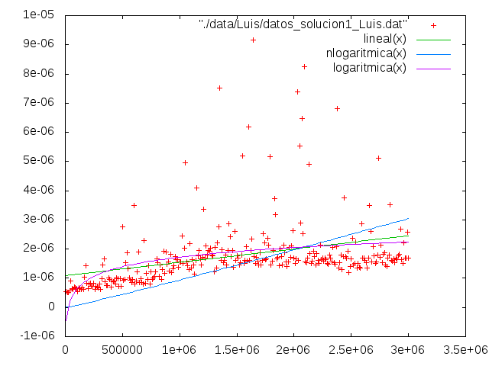
-Tabla y gŕafica de Luis(Fujitsu,Linux):

Tamaño | Tiempo
10001 | 5.38e-07
20001 | 5.25e-07
30001 | 5.15e-07
40001 | 5.7e-07
50001 | 9.15e-07
60001 | 6.54e-07
70001 | 6.3e-07
80001 | 6.95e-07
90001 | 6.68e-07
100001 | 6.39e-07
110001 | 5.31e-07
120001 | 6.83e-07
130001 | 6.41e-07
140001 | 6.17e-07
150001 | 6.83e-07
160001 | 6.19e-07
170001 | 1,04E-03
180001 | 1,42E-03
190001 | 8.2e-07
200001 | 6.57e-07
210001 | 8.14e-07
220001 | 8.35e-07
230001 | 7.37e-07
240001 | 7.21e-07
250001 | 8.33e-07
260001 | 6.32e-07
270001 | 7.13e-07
280001 | 7.09e-07
290001 | 6.61e-07
300001 | 7.95e-07
310001 | 6.32e-07
320001 | 9.93e-07
330001 | 1.46e-06
340001 | 1,66E-03
350001 | 8.88e-07
360001 | 7.42e-07
370001 | 7.39e-07
380001 | 1,01E-03
390001 | 9.49e-07
400001 | 7.05e-07
410001 | 9.08e-07
420001 | 8.92e-07
430001 | 9.02e-07
440001 | 8.09e-07
450001 | 1,01E-03
460001 | 9.88e-07
470001 | 7.19e-07
480001 | 9.75e-07
490001 | 7.25e-07
500001 | 2,76E-03
510001 | 9.36e-07
520001 | 9.53e-07
530001 | 1,55E-03
540001 | 1,89E-03
550001 | 1,33E-03
560001 | 1,02E-03
570001 | 9.29e-07
580001 | 8.6e-07
590001 | 9.59e-07
600001 | 3,50E-03
610001 | 8.07e-07
620001 | 8.96e-07
630001 | 1,23E-03
640001 | 1.9e-06
650001 | 8.56e-07
660001 | 9.9e-07
670001 | 8.56e-07
680001 | 7.94e-07
690001 | 2,29E-03
700001 | 8.4e-07
710001 | 1.16e-06
720001 | 9.58e-07
730001 | 1,44E-03
740001 | 8.1e-07
750001 | 1,21E-03
760001 | 9.53e-07
770001 | 1,02E-03
780001 | 1,05E-03
790001 | 1,21E-03
800001 | 1.66e-06
810001 | 1,54E-03
820001 | 1,07E-03
830001 | 1,46E-03
840001 | 9.5e-07
850001 | 1,30E-03
860001 | 1,93E-03
870001 | 1,18E-03
880001 | 1,91E-03
890001 | 1,49E-03
900001 | 1,55E-03
910001 | 1,25E-03
920001 | 1,81E-03
930001 | 1,20E-03
940001 | 1,32E-03
950001 | 1,43E-03
960001 | 1,74E-03
970001 | 1,63E-03
980001 | 1,63E-03
990001 | 1.39e-06
1000001 | 1,56E-03
1010001 | 1,57E-03
1020001 | 2,45E-03
1030001 | 1,51E-03
1040001 | 2,02E-03
1050001 | 4,97E-03
1060001 | 1,56E-03
1070001 | 1,44E-03
1080001 | 1.29e-06
1090001 | 2,19E-03
1100001 | 1,36E-03
1110001 | 1,63E-03
1120001 | 1,45E-03
1130001 | 1,14E-03
1140001 | 1,61E-03
1150001 | 4,09E-03
1160001 | 1,76E-03
1170001 | 1,95E-03
1180001 | 1,67E-03
1190001 | 1,44E-03
1200001 | 1,71E-03
1210001 | 3,36E-03
1220001 | 1,69E-03
1230001 | 2,11E-03
1240001 | 1,81E-03
1250001 | 1.94e-06
1260001 | 1,94E-03
1270001 | 2.02e-06
1280001 | 1,79E-03
1290001 | 1,77E-03
1300001 | 1,23E-03
1310001 | 2,04E-03
1320001 | 1,36E-03
1330001 | 2,23E-03
1340001 | 2,75E-03
1350001 | 7,52E-03
1360001 | 1,60E-03
1370001 | 1,97E-03
1380001 | 1,54E-03
1390001 | 1.61e-06
1400001 | 1.79e-06
1410001 | 1,45E-03
1420001 | 1,95E-03
1430001 | 2,87E-03
1440001 | 2.43e-06
1450001 | 1,74E-03
1460001 | 1,96E-03
1470001 | 1,39E-03
1480001 | 2,62E-03
1490001 | 1,61E-03
1500001 | 1,76E-03
1510001 | 1.68e-06
1520001 | 1,46E-03
1530001 | 1.53e-06
1540001 | 1,80E-03
1550001 | 5,20E-03
1560001 | 1,50E-03
1570001 | 1,62E-03
1580001 | 2.09e-06
1590001 | 1,59E-03
1600001 | 6,19E-03
1610001 | 1,62E-03
1620001 | 1.95e-06
1630001 | 2,35E-03
1640001 | 9,17E-03
1650001 | 1.75e-06
1660001 | 1,51E-03
1670001 | 1,73E-03
1680001 | 1,59E-03
1690001 | 1,45E-03
1700001 | 1,88E-03
1710001 | 1,45E-03
1720001 | 1,61E-03
1730001 | 2,52E-03
1740001 | 2,20E-03
1750001 | 1,63E-03
1760001 | 1,66E-03
1770001 | 2,36E-03
1780001 | 2,12E-03
1790001 | 5,18E-03
1800001 | 1,45E-03
1810001 | 1,59E-03
1820001 | 1,94E-03
1830001 | 3,72E-03
1840001 | 3,18E-03
1850001 | 1,67E-03
1860001 | 1,71E-03
1870001 | 1.44e-06
1880001 | 2,00E-03
1890001 | 1,74E-03
1900001 | 1,46E-03
1910001 | 2,15E-03
1920001 | 1,89E-03
1930001 | 1,57E-03
1940001 | 1,39E-03
1950001 | 1.56e-06
1960001 | 2.07e-06
1970001 | 1,73E-03
1980001 | 2.1e-06
1990001 | 2,63E-03
2000001 | 1,70E-03
2010001 | 1,50E-03
2020001 | 1,67E-03
2030001 | 7,38E-03
2040001 | 1,62E-03
2050001 | 5,55E-03
2060001 | 2,88E-03
2070001 | 6,47E-03
2080001 | 2,52E-03
2090001 | 8,26E-03
2100001 | 1,57E-03
2110001 | 1.53e-06
2120001 | 1,69E-03
2130001 | 4,91E-03
2140001 | 1,84E-03
2150001 | 1,50E-03
2160001 | 1,59E-03
2170001 | 1,93E-03
2180001 | 1,75E-03
2190001 | 1,46E-03
2200001 | 1,86E-03
2210001 | 1,62E-03
2220001 | 1.51e-06
2230001 | 2,13E-03
2240001 | 1.63e-06
2250001 | 1,70E-03
2260001 | 1,59E-03
2270001 | 1,69E-03
2280001 | 1,63E-03
2290001 | 1,51E-03
2300001 | 1,47E-03
2310001 | 1,81E-03
2320001 | 1,69E-03
2330001 | 1,56E-03
2340001 | 2,05E-03
2350001 | 1,55E-03
2360001 | 1,49E-03
2370001 | 2.08e-06
2380001 | 6,82E-03
2390001 | 1.36e-06
2400001 | 1,53E-03
2410001 | 1,81E-03
2420001 | 1,30E-03
2430001 | 1,75E-03
2440001 | 3,76E-03
2450001 | 1,74E-03
2460001 | 1,70E-03
2470001 | 1,92E-03
2480001 | 1,20E-03
2490001 | 1,40E-03
2500001 | 1,68E-03
2510001 | 2,38E-03
2520001 | 1,46E-03
2530001 | 1,51E-03
2540001 | 2,23E-03
2550001 | 1,35E-03
2560001 | 1,51E-03
2570001 | 1,38E-03
2580001 | 1,34E-03
2590001 | 2,86E-03
2600001 | 1,70E-03
2610001 | 1,70E-03
2620001 | 1,62E-03
2630001 | 1,52E-03
2640001 | 1,35E-03
2650001 | 1,69E-03
2660001 | 3.5e-06
2670001 | 2,60E-03
2680001 | 1,57E-03
2690001 | 2,08E-03
2700001 | 1,78E-03
2710001 | 1,50E-03
2720001 | 1,57E-03
2730001 | 1,79E-03
2740001 | 5,12E-03
2750001 | 1,73E-03
2760001 | 2,14E-03
2770001 | 1,54E-03
2780001 | 1,82E-03
2790001 | 1,86E-03
2800001 | 1,47E-03
2810001 | 1.4e-06
2820001 | 1,70E-03
2830001 | 1,79E-03
2840001 | 3,52E-03
2850001 | 1,61E-03
2860001 | 1,58E-03
2870001 | 1,67E-03
2880001 | 1,53E-03
2890001 | 1,70E-03
2900001 | 1.63e-06
2910001 | 1,78E-03
2920001 | 1,82E-03
2930001 | 2.68e-06
2940001 | 1,63E-03
2950001 | 1,51E-03
2960001 | 2.22e-06
2970001 | 1.7e-06
2980001 | 1,68E-03
2990001 | 2,59E-03
3000001 | 1,69E-03

-Tabla y gŕafica de Miguel(Toshiba,Windows):

Tamaño | Tiempo
10001 | 4.27654e-007
20001 | 4.27654e-007
30001 | 4.27654e-007
40001 | 4.27654e-007
50001 | 8.55308e-007
60001 | 4.27654e-007
70001 | 8.55308e-007
80001 | 4.27654e-007
90001 | 8.55308e-007
100001 | 4.27654e-007
110001 | 4.27654e-007
120001 | 8.55308e-007
130001 | 4.27654e-007
140001 | 4.27654e-007
150001 | 4.27654e-007
160001 | 4.27654e-007
170001 | 4.27654e-007
180001 | 4.27654e-007
190001 | 8.55308e-007
200001 | 4.27654e-007
210001 | 8.55308e-007
220001 | 4.27654e-007
230001 | 4.27654e-007
240001 | 4.27654e-007
250001 | 4.27654e-007
260001 | 4.27654e-007
270001 | 4.27654e-007
280001 | 8.55308e-007
290001 | 4.27654e-007
300001 | 8.55308e-007
310001 | 8.55308e-007
320001 | 8.55308e-007
330001 | 8.55308e-007
340001 | 8.55308e-007
350001 | 8.55308e-007
360001 | 4.27654e-007
370001 | 8.55308e-007
380001 | 5.13185e-006
390001 | 8.55308e-007
400001 | 8.55308e-007
410001 | 8.55308e-007
420001 | 4.27654e-007
430001 | 8.55308e-007
440001 | 4.27654e-007
450001 | 8.55308e-007
460001 | 8.55308e-007
470001 | 8.55308e-007
480001 | 4.27654e-007
490001 | 8.55308e-007
500001 | 8.55308e-007
510001 | 8.55308e-007
520001 | 4.27654e-007
530001 | 8.55308e-007
540001 | 4.27654e-007
550001 | 8.55308e-007
560001 | 4.27654e-007
570001 | 8.55308e-007
580001 | 8.55308e-007
590001 | 8.55308e-007
600001 | 8.55308e-007
610001 | 4.27654e-007
620001 | 4.27654e-007
630001 | 4.27654e-007
640001 | 8.55308e-007
650001 | 8.55308e-007
660001 | 8.55308e-007
670001 | 8.55308e-007
680001 | 8.55308e-007
690001 | 1.28296e-006
700001 | 4.27654e-007
710001 | 8.55308e-007
720001 | 8.55308e-007
730001 | 4.27654e-007
740001 | 4.27654e-007
750001 | 8.55308e-007
760001 | 4.27654e-007
770001 | 8.55308e-007
780001 | 8.55308e-007
790001 | 4.27654e-007
800001 | 8.55308e-007
810001 | 8.55308e-007
820001 | 4.27654e-007
830001 | 4.27654e-007
840001 | 4.27654e-007
850001 | 1.28296e-006
860001 | 8.55308e-007
870001 | 8.55308e-007
880001 | 1.28296e-006
890001 | 8.55308e-007
900001 | 8.55308e-007
910001 | 4.27654e-007
920001 | 8.55308e-007
930001 | 8.55308e-007
940001 | 8.55308e-007
950001 | 4.27654e-007
960001 | 4.27654e-007
970001 | 4.27654e-007
980001 | 8.55308e-007
990001 | 8.55308e-007
1000001 | 8.55308e-007
1010001 | 8.55308e-007
1020001 | 8.55308e-007
1030001 | 4.27654e-007
1040001 | 8.55308e-007
1050001 | 4.27654e-007
1060001 | 8.55308e-007
1070001 | 8.55308e-007
1080001 | 4.27654e-007
1090001 | 1.71062e-006
1100001 | 8.55308e-007
1110001 | 4.27654e-007
1120001 | 8.55308e-007
1130001 | 4.27654e-007
1140001 | 3.42123e-006
1150001 | 8.55308e-007
1160001 | 8.55308e-007
1170001 | 8.55308e-007
1180001 | 1.28296e-006
1190001 | 8.55308e-007
1200001 | 8.55308e-007
1210001 | 8.55308e-007
1220001 | 1.28296e-006
1230001 | 4.27654e-007
1240001 | 8.55308e-007
1250001 | 1.28296e-006
1260001 | 4.27654e-007
1270001 | 8.55308e-007
1280001 | 8.55308e-007
1290001 | 8.55308e-007
1300001 | 8.55308e-007
1310001 | 8.55308e-007
1320001 | 8.55308e-007
1330001 | 8.55308e-007
1340001 | 8.55308e-007
1350001 | 8.55308e-007
1360001 | 8.55308e-007
1370001 | 8.55308e-007
1380001 | 8.55308e-007
1390001 | 4.27654e-007
1400001 | 8.55308e-007
1410001 | 8.55308e-007
1420001 | 8.55308e-007
1430001 | 8.55308e-007
1440001 | 8.55308e-007
1450001 | 8.55308e-007
1460001 | 1.28296e-006
1470001 | 4.27654e-007
1480001 | 1.28296e-006
1490001 | 8.55308e-007
1500001 | 8.55308e-007
1510001 | 8.55308e-007
1520001 | 8.55308e-007
1530001 | 8.55308e-007
1540001 | 8.55308e-007
1550001 | 8.55308e-007
1560001 | 8.55308e-007
1570001 | 1.28296e-006
1580001 | 8.55308e-007
1590001 | 8.55308e-007
1600001 | 8.55308e-007
1610001 | 8.55308e-007
1620001 | 8.55308e-007
1630001 | 8.55308e-007
1640001 | 8.55308e-007
1650001 | 1.28296e-006
1660001 | 1.28296e-006
1670001 | 1.71062e-006
1680001 | 1.28296e-006
1690001 | 4.27654e-007
1700001 | 8.55308e-007
1710001 | 1.28296e-006
1720001 | 8.55308e-007
1730001 | 1.71062e-006
1740001 | 2.13827e-006
1750001 | 8.55308e-007
1760001 | 1.28296e-006
1770001 | 1.28296e-006
1780001 | 8.55308e-007
1790001 | 1.28296e-006
1800001 | 8.55308e-007
1810001 | 1.28296e-006
1820001 | 8.55308e-007
1830001 | 1.28296e-006
1840001 | 8.55308e-007
1850001 | 8.55308e-007
1860001 | 8.55308e-007
1870001 | 8.55308e-007
1880001 | 3.84889e-006
1890001 | 8.55308e-007
1900001 | 1.28296e-006
1910001 | 1.28296e-006
1920001 | 4.27654e-007
1930001 | 8.55308e-007
1940001 | 8.55308e-007
1950001 | 8.55308e-007
1960001 | 8.55308e-007
1970001 | 8.55308e-007
1980001 | 8.55308e-007
1990001 | 8.55308e-007
2000001 | 1.71062e-006
2010001 | 1.28296e-006
2020001 | 1.28296e-006
2030001 | 1.71062e-006
2040001 | 1.71062e-006
2050001 | 8.55308e-007
2060001 | 1.28296e-006
2070001 | 4.27654e-007
2080001 | 8.55308e-007
2090001 | 8.55308e-007
2100001 | 1.28296e-006
2110001 | 8.55308e-007
2120001 | 8.55308e-007
2130001 | 1.28296e-006
2140001 | 8.55308e-007
2150001 | 4.27654e-007
2160001 | 8.55308e-007
2170001 | 8.55308e-007
2180001 | 8.55308e-007
2190001 | 8.55308e-007
2200001 | 8.55308e-007
2210001 | 8.55308e-007
2220001 | 4.27654e-007
2230001 | 8.55308e-007
2240001 | 1.28296e-006
2250001 | 1.28296e-006
2260001 | 8.55308e-007
2270001 | 8.55308e-007
2280001 | 8.55308e-007
2290001 | 8.55308e-007
2300001 | 8.55308e-007
2310001 | 8.55308e-007
2320001 | 8.55308e-007
2330001 | 1.71062e-006
2340001 | 8.55308e-007
2350001 | 8.55308e-007
2360001 | 1.28296e-006
2370001 | 8.55308e-007
2380001 | 8.55308e-007
2390001 | 4.27654e-007
2400001 | 8.55308e-007
2410001 | 4.27654e-007
2420001 | 8.55308e-007
2430001 | 8.55308e-007
2440001 | 8.55308e-007
2450001 | 8.55308e-007
2460001 | 1.71062e-006
2470001 | 8.55308e-007
2480001 | 8.55308e-007
2490001 | 8.55308e-007
2500001 | 8.55308e-007
2510001 | 8.55308e-007
2520001 | 8.55308e-007
2530001 | 8.55308e-007
2540001 | 4.27654e-007
2550001 | 4.27654e-007
2560001 | 8.55308e-007
2570001 | 8.55308e-007
2580001 | 8.55308e-007
2590001 | 2.99358e-006
2600001 | 4.27654e-007
2610001 | 8.55308e-007
2620001 | 1.28296e-006
2630001 | 8.55308e-007
2640001 | 8.55308e-007
2650001 | 8.55308e-007
2660001 | 8.55308e-007
2670001 | 1.28296e-006
2680001 | 8.55308e-007
2690001 | 4.27654e-007
2700001 | 8.55308e-007
2710001 | 8.55308e-007
2720001 | 8.55308e-007
2730001 | 8.55308e-007
2740001 | 1.28296e-006
2750001 | 8.55308e-007
2760001 | 4.27654e-007
2770001 | 8.55308e-007
2780001 | 8.55308e-007
2790001 | 1.28296e-006
2800001 | 8.55308e-007
2810001 | 1.28296e-006
2820001 | 1.28296e-006
2830001 | 1.28296e-006
2840001 | 8.55308e-007
2850001 | 8.55308e-007
2860001 | 1.28296e-006
2870001 | 1.71062e-006
2880001 | 8.55308e-007
2890001 | 8.55308e-007
2900001 | 8.55308e-007
2910001 | 1.28296e-006
2920001 | 1.28296e-006
2930001 | 1.28296e-006
2940001 | 1.28296e-006
2950001 | 8.55308e-007
2960001 | 1.28296e-006
2970001 | 8.55308e-007
2980001 | 1.28296e-006
2990001 | 8.55308e-007
3000001 | 1.28296e-006

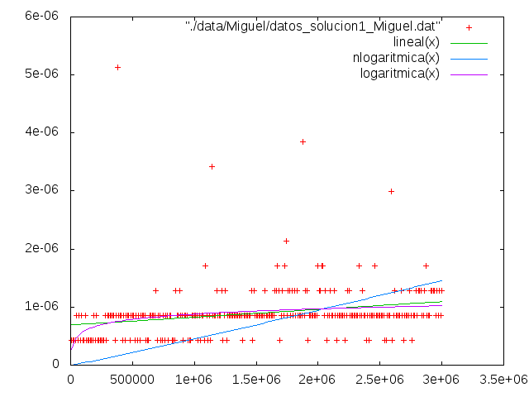
-Tabla y gŕafica de Diego(MacBook Pro,MacOS El Capitán):

Tamaño | Tiempo
10001 | 6.32e-07
20001 | 8.81e-07
30001 | 1,03E-003
40001 | 9.8e-07
50001 | 7.97e-07
60001 | 8.5e-07
70001 | 8.73e-07
80001 | 9.93e-07
90001 | 7.97e-07
100001 | 7.32e-07
110001 | 9.24e-07
120001 | 1,05E-003
130001 | 2,04E-003
140001 | 6.74e-07
150001 | 7.88e-07
160001 | 7.73e-07
170001 | 7.93e-07
180001 | 7.54e-07
190001 | 7.2e-07
200001 | 7.85e-07
210001 | 7.48e-07
220001 | 9.95e-07
230001 | 7.35e-07
240001 | 8.44e-07
250001 | 9.41e-07
260001 | 7.51e-07
270001 | 1,00E-003
280001 | 7.06e-07
290001 | 1,36E-003
300001 | 8.46e-07
310001 | 8.52e-07
320001 | 8.57e-07
330001 | 1,43E-003
340001 | 9.36e-07
350001 | 1,02E-003
360001 | 1,08E-003
370001 | 1,04E-003
380001 | 8.15e-07
390001 | 7.89e-07
400001 | 9.87e-07
410001 | 2,32E-003
420001 | 1,18E-003
430001 | 1,08E-003
440001 | 9.72e-07
450001 | 9.13e-07
460001 | 9.78e-07
470001 | 1,36E-003
480001 | 1,10E-003
490001 | 7.99e-07
500001 | 2,65E-003
510001 | 1,40E-003
520001 | 9.56e-07
530001 | 1,88E-003
540001 | 1.18e-06
550001 | 9.22e-07
560001 | 1,25E-003
570001 | 1.0517e-05
580001 | 1,26E-003
590001 | 1,47E-003
600001 | 1,18E-003
610001 | 1,36E-003
620001 | 1.15e-06
630001 | 1,06E-003
640001 | 2.18e-06
650001 | 1,93E-003
660001 | 1.3e-06
670001 | 9.56e-07
680001 | 1,51E-003
690001 | 1,12E-003
700001 | 1,18E-003
710001 | 1,67E-003
720001 | 1.69e-06
730001 | 1,68E-003
740001 | 1,35E-003
750001 | 1,63E-003
760001 | 1,71E-003
770001 | 1,18E-003
780001 | 8.05e-07
790001 | 2,77E-003
800001 | 1.31e-06
810001 | 1,60E-003
820001 | 1,05E-003
830001 | 1,23E-003
840001 | 1,73E-003
850001 | 1,63E-003
860001 | 1,76E-003
870001 | 1,64E-003
880001 | 1,85E-003
890001 | 1,84E-003
900001 | 1,11E-003
910001 | 2,61E-003
920001 | 1,14E-003
930001 | 1.84e-06
940001 | 1.49e-06
950001 | 1,68E-003
960001 | 1.19e-06
970001 | 1,51E-003
980001 | 1,37E-003
990001 | 1,53E-003
1000001 | 1,87E-003
1010001 | 1,28E-003
1020001 | 1,64E-003
1030001 | 1,63E-003
1040001 | 1,74E-003
1050001 | 1,57E-003
1060001 | 1,85E-003
1070001 | 1,72E-003
1080001 | 2,13E-003
1090001 | 1,21E-003
1100001 | 1,25E-003
1110001 | 1,45E-003
1120001 | 2,70E-003
1130001 | 1,70E-003
1140001 | 1,28E-003
1150001 | 1,13E-003
1160001 | 1,24E-003
1170001 | 1,79E-003
1180001 | 1,53E-003
1190001 | 1.78e-06
1200001 | 1,78E-003
1210001 | 1.57e-06
1220001 | 1,66E-003
1230001 | 1,62E-003
1240001 | 1,56E-003
1250001 | 1,32E-003
1260001 | 1,71E-003
1270001 | 1,17E-003
1280001 | 2,06E-003
1290001 | 1,48E-003
1300001 | 2,10E-003
1310001 | 1,69E-003
1320001 | 1,86E-003
1330001 | 2,39E-003
1340001 | 1,79E-003
1350001 | 1,37E-003
1360001 | 1,77E-003
1370001 | 1,53E-003
1380001 | 2.06e-06
1390001 | 2,22E-003
1400001 | 1,94E-003
1410001 | 1,97E-003
1420001 | 1,56E-003
1430001 | 1,89E-003
1440001 | 1,81E-003
1450001 | 2,18E-003
1460001 | 2,08E-003
1470001 | 2,34E-003
1480001 | 1,46E-003
1490001 | 1,75E-003
1500001 | 1,29E-003
1510001 | 1,99E-003
1520001 | 2,11E-003
1530001 | 1,96E-003
1540001 | 2,20E-003
1550001 | 1,63E-003
1560001 | 3.02e-06
1570001 | 1.94e-06
1580001 | 1,63E-003
1590001 | 1,74E-003
1600001 | 2,01E-003
1610001 | 1,93E-003
1620001 | 1.84e-06
1630001 | 1,44E-003
1640001 | 2,10E-003
1650001 | 1,67E-003
1660001 | 1,64E-003
1670001 | 1,86E-003
1680001 | 1,66E-003
1690001 | 2.19e-06
1700001 | 2,51E-003
1710001 | 1,76E-003
1720001 | 1,71E-003
1730001 | 1,53E-003
1740001 | 1,60E-003
1750001 | 1,97E-003
1760001 | 1,70E-003
1770001 | 1,68E-003
1780001 | 1,69E-003
1790001 | 1,62E-003
1800001 | 2,04E-003
1810001 | 1,93E-003
1820001 | 1,76E-003
1830001 | 2,66E-003
1840001 | 1,72E-003
1850001 | 1,72E-003
1860001 | 1,88E-003
1870001 | 3,40E-003
1880001 | 1,92E-003
1890001 | 2,06E-003
1900001 | 2,65E-003
1910001 | 2,15E-003
1920001 | 1,91E-003
1930001 | 1,87E-003
1940001 | 1,85E-003
1950001 | 2,21E-003
1960001 | 1,92E-003
1970001 | 1,76E-003
1980001 | 2,62E-003
1990001 | 1,68E-003
2000001 | 1,85E-003
2010001 | 1,98E-003
2020001 | 1,89E-003
2030001 | 1,88E-003
2040001 | 2,12E-003
2050001 | 2,05E-003
2060001 | 1,81E-003
2070001 | 2,00E-003
2080001 | 2,04E-003
2090001 | 1,82E-003
2100001 | 1,66E-003
2110001 | 1,65E-003
2120001 | 1,61E-003
2130001 | 2,92E-003
2140001 | 2,17E-003
2150001 | 1,72E-003
2160001 | 1,97E-003
2170001 | 2,44E-003
2180001 | 1,79E-003
2190001 | 1,78E-003
2200001 | 2,04E-003
2210001 | 1,83E-003
2220001 | 1,84E-003
2230001 | 1,74E-003
2240001 | 1.81e-06
2250001 | 2,05E-003
2260001 | 1,82E-003
2270001 | 1,72E-003
2280001 | 1,85E-003
2290001 | 1,84E-003
2300001 | 1,73E-003
2310001 | 1.73e-06
2320001 | 1,79E-003
2330001 | 1,97E-003
2340001 | 2,08E-003
2350001 | 1,97E-003
2360001 | 2,35E-003
2370001 | 1,75E-003
2380001 | 1,72E-003
2390001 | 1,80E-003
2400001 | 1,92E-003
2410001 | 1,95E-003
2420001 | 2,59E-003
2430001 | 1,97E-003
2440001 | 1,99E-003
2450001 | 2,03E-003
2460001 | 1,85E-003
2470001 | 1.75e-06
2480001 | 1,77E-003
2490001 | 2,26E-003
2500001 | 1,70E-003
2510001 | 1,83E-003
2520001 | 2,40E-003
2530001 | 1,76E-003
2540001 | 1,87E-003
2550001 | 1,86E-003
2560001 | 1.82e-06
2570001 | 1,95E-003
2580001 | 1,78E-003
2590001 | 1,96E-003
2600001 | 1,80E-003
2610001 | 1,69E-003
2620001 | 2,19E-003
2630001 | 1,95E-003
2640001 | 2,03E-003
2650001 | 3,25E-003
2660001 | 1,83E-003
2670001 | 1,61E-003
2680001 | 1,79E-003
2690001 | 1,57E-003
2700001 | 2,23E-003
2710001 | 2,24E-003
2720001 | 2,02E-003
2730001 | 1,90E-003
2740001 | 2,03E-003
2750001 | 2,15E-003
2760001 | 2,51E-003
2770001 | 2,06E-003
2780001 | 2,59E-003
2790001 | 1,75E-003
2800001 | 2.02e-06
2810001 | 2,76E-003
2820001 | 2,36E-003
2830001 | 1,98E-003
2840001 | 2,82E-003
2850001 | 2,01E-003
2860001 | 1,69E-003
2870001 | 3,00E-003
2880001 | 1,71E-003
2890001 | 2,03E-003
2900001 | 2,60E-003
2910001 | 1,94E-003
2920001 | 2,12E-003
2930001 | 2,97E-003
2940001 | 1,68E-003
2950001 | 1,92E-003
2960001 | 2,63E-003
2970001 | 1,85E-003
2980001 | 1,86E-003
2990001 | 2,57E-003
3000001 | 1,76E-003
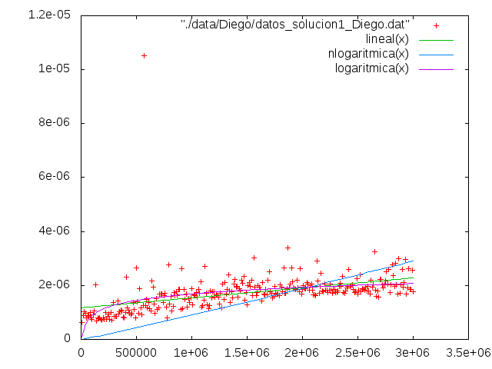

1.3 Segunda Solución DyV

En esta segunda solución que planteamos para nuestro problema comenzaremos como en la anterior, presentando el código:

#include <iostream>
using namespace std;
#include <ctime>
#include <cstdlib>
#include <climits>
#include <cassert>
//#include <mach/mach_time.h>
#include <cstdio>
#include <chrono>

int & rift_lims(int* arr, int beg, int end, int & res){

int N = end - beg;

if (N == 1) {
res = beg;
return arr[beg];
}
else if (arr [beg + N/2 - 1] < arr [end - 1])
return rift_lims(arr, beg + N/2 , end, res);
else
return rift_lims(arr,beg, beg + N/2, res);
}

int rift(int * arr, int n, int & res){

int beg = 0, end = n;

return rift_lims(arr,beg,end,res);
}

double uniforme()
{
double u;
u = (double) rand();
u = u/(double)(RAND_MAX+1.0);
return u;
}

int main(int argc, char * argv[])
{

if (argc != 2)
{
cerr << "Formato " << argv[0] << " <num_elem>" << endl;
return -1;
}

int n = atoi(argv[1]);

int * T = new int[n];
assert(T);

srand(time(0));
double u=uniforme();
int p=1+(int)((n-2)*u);
T[p]=n-1;
for (int i=0; i<p; i++) T[i]=i;
for (int i=p+1; i<n; i++) T[i]=n-1-i+p;

#ifdef _PRINT_IT_
cout << "El vector generado es:" << endl;
for (int j=0; j<n; j++) {cout << T[j] << " ";}
cout << endl;
#endif

int res=0;
std::chrono::high_resolution_clock::time_point t1, t2;

t1=std::chrono::high_resolution_clock::now();
rift(T,n,res);
t2=std::chrono::high_resolution_clock::now();
int punto_cambio=res;

std::chrono::duration<double> transcurrido = std::chrono::duration_cast<std::chrono::duration<double> >(t2-t1);
cout << n << " " << transcurrido.count() << "\n";

#ifdef _PRINT_IT_
cout << endl << "La posicion en la que cambia la monotonia es: " << punto_cambio << endl ;
#endif
}

El algoritmo utilizado en esta segunda solución es el siguiente:
1) Aprovechando la estructura con la que se genera el vector aleatorio tomamos inicialmente el punto medio y el extremo derecho del vector. Si el valor almacenado en el punto medio es mayor que el almacenado en el punto extremo tomamos la parte izquierda del vector. Si el valor almacenado en el punto medio es menor que el del extremo tomaremos la parte derecha del vector.
2) Repetiremos esto hasta llegar al caso en que el tamaño del vector sea 1 y por tanto el punto sea el único que nos queda.

La eficiencia de este algoritmo es logarítmica como se observa en la suma al cuadrado de los residuos que nos arroja el ajuste de las funciones mediante gnuplot:
nlogarítmica = 1.0888e-10
logarítmica = 6.58058e-11

Pasamos a exponer los datos y gráficas obtenidas:

Datos:
-Tabla y gŕafica de Nacho(Toshiba,Linux):

Tamaño | Tiempo
1 | 1.34e-07
5001 | 3.71e-07
10001 | 4.65e-07
15001 | 7.23e-07
20001 | 5.42e-07
25001 | 5.18e-07
30001 | 6.48e-07
35001 | 6.85e-07
40001 | 6.48e-07
45001 | 7.77e-07
50001 | 1,01E-003
55001 | 8,00E-007
60001 | 1,65E-003
65001 | 1,30E-003
70001 | 1,51E-003
75001 | 1,08E-003
80001 | 9.79e-07
85001 | 1,08E-003
90001 | 1,40E-003
95001 | 6.52e-07
100001 | 5.43e-07
105001 | 4.48e-07
110001 | 4.66e-07
115001 | 5.67e-07
120001 | 5.42e-07
125001 | 5.41e-07
130001 | 4.64e-07
135001 | 4.82e-07
140001 | 4.95e-07
145001 | 6.45e-07
150001 | 5.29e-07
155001 | 5.54e-07
160001 | 5.85e-07
165001 | 6.48e-07
170001 | 5.65e-07
175001 | 5.44e-07
180001 | 5.57e-07
185001 | 6.91e-07
190001 | 5.38e-07
195001 | 6.32e-07
200001 | 5,37E-003
205001 | 1.06e-06
210001 | 8.08e-07
215001 | 9.24e-07
220001 | 9.12e-07
225001 | 4.86e-07
230001 | 5.44e-07
235001 | 2,87E-003
240001 | 6.74e-07
245001 | 5.3e-07
250001 | 4.99e-07
255001 | 9.51e-07
260001 | 7.32e-07
265001 | 8.61e-07
270001 | 6.55e-07
275001 | 8.5e-07
280001 | 6.63e-07
285001 | 6.71e-07
290001 | 8.31e-07
295001 | 6.98e-07
300001 | 6.29e-07
305001 | 6.02e-07
310001 | 5.59e-07
315001 | 5.97e-07
320001 | 6.24e-07
325001 | 5.7e-07
330001 | 1,57E-003
335001 | 7.67e-07
340001 | 7.46e-07
345001 | 6.87e-07
350001 | 6.92e-07
355001 | 5.52e-07
360001 | 6.64e-07
365001 | 2,30E-003
370001 | 7.07e-07
375001 | 5.12e-07
380001 | 7.48e-07
385001 | 6.69e-07
390001 | 6.86e-07
395001 | 1,18E-003
400001 | 1,07E-003
405001 | 7.38e-07
410001 | 6.94e-07
415001 | 5.86e-07
420001 | 9.21e-07
425001 | 1,16E-003
430001 | 1,10E-003
435001 | 7.87e-07
440001 | 6.62e-07
445001 | 1,18E-003
450001 | 1,17E-003
455001 | 8.52e-07
460001 | 7.28e-07
465001 | 6.49e-07
470001 | 1,85E-003
475001 | 9.92e-07
480001 | 7.9e-07
485001 | 7.95e-07
490001 | 8.13e-07
495001 | 9.6e-07
500001 | 1,04E-003
505001 | 9.72e-07
510001 | 8.53e-07
515001 | 6.87e-07
520001 | 8.4e-07
525001 | 8.02e-07
530001 | 8.37e-07
535001 | 7.8e-07
540001 | 7.9e-07
545001 | 9.61e-07
550001 | 9.27e-07
555001 | 7.75e-07
560001 | 9.06e-07
565001 | 6.97e-07
570001 | 7.61e-07
575001 | 9.99e-07
580001 | 7.22e-07
585001 | 7.76e-07
590001 | 8.43e-07
595001 | 8.35e-07
600001 | 1,22E-003
605001 | 6.98e-07
610001 | 6.41e-07
615001 | 7.57e-07
620001 | 7.51e-07
625001 | 1,57E-003
630001 | 9.71e-07
635001 | 7.9e-07
640001 | 9.72e-07
645001 | 5,49E-003
650001 | 1,03E-003
655001 | 9.92e-07
660001 | 8.6e-07
665001 | 7.13e-07
670001 | 1,79E-003
675001 | 8.22e-07
680001 | 9.47e-07
685001 | 9.41e-07
690001 | 1.6e-06
695001 | 8.41e-07
700001 | 9.45e-07
705001 | 1,24E-003
710001 | 1,17E-003
715001 | 1,30E-003
720001 | 8.45e-07
725001 | 7.68e-07
730001 | 1,43E-003
735001 | 1,46E-003
740001 | 1,38E-003
745001 | 1,58E-003
750001 | 1,36E-003
755001 | 4.69e-07
760001 | 7.21e-07
765001 | 6.44e-07
770001 | 5.44e-07
775001 | 5.45e-07
780001 | 5.01e-07
785001 | 5.1e-07
790001 | 1,85E-003
795001 | 6.2e-07
800001 | 7.57e-07
805001 | 5.77e-07
810001 | 6.05e-07
815001 | 7.31e-07
820001 | 5.32e-07
825001 | 6.13e-07
830001 | 4.91e-07
835001 | 7.02e-07
840001 | 5.54e-07
845001 | 5.18e-07
850001 | 5.25e-07
855001 | 8.97e-07
860001 | 5.38e-07
865001 | 5.45e-07
870001 | 4.3e-07
875001 | 5.95e-07
880001 | 6.2e-07
885001 | 5.57e-07
890001 | 5.27e-07
895001 | 1,01E-003
900001 | 5.95e-07
905001 | 5.87e-07
910001 | 5.57e-07
915001 | 6.36e-07
920001 | 5.43e-07
925001 | 5.71e-07
930001 | 4.02e-07
935001 | 6.4e-07
940001 | 5.78e-07
945001 | 9.07e-07
950001 | 5.37e-07
955001 | 5.78e-07
960001 | 6.04e-07
965001 | 5.02e-07
970001 | 5.95e-07
975001 | 6.16e-07
980001 | 4.86e-07
985001 | 5.34e-07
990001 | 5.72e-07
995001 | 8.5e-07
1000001 | 5.71e-07

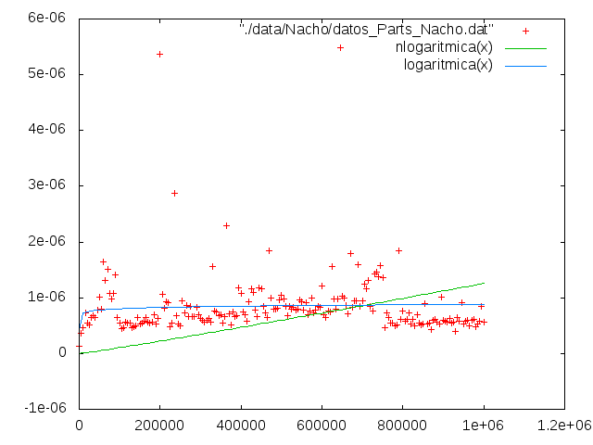
-Tabla y gŕafica de Luis(Fujitsu,Linux):

Tamaño | Tiempo
1 | 2.19e-07
5001 | 4.42e-07
10001 | 4.13e-07
15001 | 4.04e-07
20001 | 4.16e-07
25001 | 4.43e-07
30001 | 4.42e-07
35001 | 5.34e-07
40001 | 4.08e-07
45001 | 9.12e-07
50001 | 6.3e-07
55001 | 8.93e-07
60001 | 4.91e-07
65001 | 4.79e-07
70001 | 5.8e-07
75001 | 5.62e-07
80001 | 5.65e-07
85001 | 5.3e-07
90001 | 6.8e-07
95001 | 6.4e-07
100001 | 1,09E-003
105001 | 1,77E-003
110001 | 8.01e-07
115001 | 7.36e-07
120001 | 7.04e-07
125001 | 7.07e-07
130001 | 6.76e-07
135001 | 7.59e-07
140001 | 4.74e-07
145001 | 1.2453e-05
150001 | 5.95e-07
155001 | 2,91E-003
160001 | 1,05E-003
165001 | 6.61e-07
170001 | 7.47e-07
175001 | 6.63e-07
180001 | 7.07e-07
185001 | 6.28e-07
190001 | 7.89e-07
195001 | 8.39e-07
200001 | 3,21E-003
205001 | 1,03E-003
210001 | 9.16e-07
215001 | 7.6e-07
220001 | 9.73e-07
225001 | 1,06E-003
230001 | 8.9e-07
235001 | 7.19e-07
240001 | 7.15e-07
245001 | 4,16E-003
250001 | 7.56e-07
255001 | 9.84e-07
260001 | 8.19e-07
265001 | 8.82e-07
270001 | 8.69e-07
275001 | 1,07E-003
280001 | 3,73E-003
285001 | 1,18E-003
290001 | 7.71e-07
295001 | 9.32e-07
300001 | 6.11e-07
305001 | 9.04e-07
310001 | 8.47e-07
315001 | 7.55e-07
320001 | 2,69E-003
325001 | 8.17e-07
330001 | 9.2e-07
335001 | 7.97e-07
340001 | 9.46e-07
345001 | 7.06e-07
350001 | 1,01E-003
355001 | 1.3e-06
360001 | 1,01E-003
365001 | 8.94e-07
370001 | 1,04E-003
375001 | 8.23e-07
380001 | 1,07E-003
385001 | 1,24E-003
390001 | 1,16E-003
395001 | 1,01E-003
400001 | 1,35E-003
405001 | 1,09E-003
410001 | 8.66e-07
415001 | 9.32e-07
420001 | 7.98e-07
425001 | 8.2e-07
430001 | 8.13e-07
435001 | 9.59e-07
440001 | 1,58E-003
445001 | 1.24e-06
450001 | 1,34E-003
455001 | 9.76e-07
460001 | 9.02e-07
465001 | 8.29e-07
470001 | 1,06E-003
475001 | 1,26E-003
480001 | 9.03e-07
485001 | 1,13E-003
490001 | 8.8e-07
495001 | 1,32E-003
500001 | 1,38E-003
505001 | 1,37E-003
510001 | 1,05E-003
515001 | 1,33E-003
520001 | 8.37e-07
525001 | 1,06E-003
530001 | 9.95e-07
535001 | 8.42e-07
540001 | 1,06E-003
545001 | 1,27E-003
550001 | 1,02E-003
555001 | 7.93e-07
560001 | 1,01E-003
565001 | 8.61e-07
570001 | 9.86e-07
575001 | 1,46E-003
580001 | 1,23E-003
585001 | 7.21e-07
590001 | 1,22E-003
595001 | 1,67E-003
600001 | 1,43E-003
605001 | 9.9e-07
610001 | 1,07E-003
615001 | 1,15E-003
620001 | 8.14e-07
625001 | 8.82e-07
630001 | 2,02E-003
635001 | 1,31E-003
640001 | 7.59e-07
645001 | 8.73e-07
650001 | 1,24E-003
655001 | 1,02E-003
660001 | 8.39e-07
665001 | 1,17E-003
670001 | 4,10E-003
675001 | 1,21E-003
680001 | 9.38e-07
685001 | 5,95E-003
690001 | 1,20E-003
695001 | 6.64e-07
700001 | 1,32E-003
705001 | 1,07E-003
710001 | 1.3e-06
715001 | 9.98e-07
720001 | 8.94e-07
725001 | 1,43E-003
730001 | 1,55E-003
735001 | 7.43e-07
740001 | 9.66e-07
745001 | 5,13E-003
750001 | 1.69e-06
755001 | 8.74e-07
760001 | 6.24e-07
765001 | 1,29E-003
770001 | 8.49e-07
775001 | 1,13E-003
780001 | 1,73E-003
785001 | 1,24E-003
790001 | 1,46E-003
795001 | 8.03e-07
800001 | 9.92e-07
805001 | 9.59e-07
810001 | 1,35E-003
815001 | 1,21E-003
820001 | 8.3e-07
825001 | 1.49e-06
830001 | 1,58E-003
835001 | 8.47e-07
840001 | 1,09E-003
845001 | 1,07E-003
850001 | 1.94e-06
855001 | 1,07E-003
860001 | 1,05E-003
865001 | 1,31E-003
870001 | 1,38E-003
875001 | 8.39e-07
880001 | 7.52e-07
885001 | 4,03E-003
890001 | 8.14e-07
895001 | 7.49e-07
900001 | 6.65e-07
905001 | 1,19E-003
910001 | 1,18E-003
915001 | 1,22E-003
920001 | 1,45E-003
925001 | 1,16E-003
930001 | 1,07E-003
935001 | 1,59E-003
940001 | 1,97E-003
945001 | 9.96e-07
950001 | 1,15E-003
955001 | 1,29E-003
960001 | 1,92E-003
965001 | 1,33E-003
970001 | 1,48E-003
975001 | 8.06e-07
980001 | 1.33e-06
985001 | 1.62e-06
990001 | 1,56E-003
995001 | 1,04E-003
1000001 | 1,58E-003

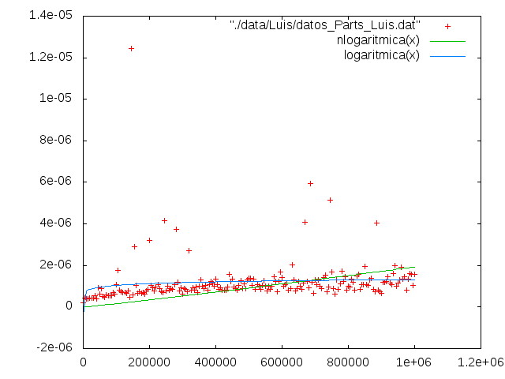
-Tabla y gŕafica de Miguel(Toshiba, Windows):

Tamaño | Tiempo
1 | 0,00E+000
10001 | 4.27654e-007
20001 | 4.27654e-007
30001 | 0,00E+000
40001 | 4.27654e-007
50001 | 4.27654e-007
60001 | 4.27654e-007
70001 | 4.27654e-007
80001 | 0,00E+000
90001 | 4.27654e-007
100001 | 4.27654e-007
110001 | 4.27654e-007
120001 | 0,00E+000
130001 | 4.27654e-007
140001 | 4.27654e-007
150001 | 4.27654e-007
160001 | 0,00E+000
170001 | 4.27654e-007
180001 | 4.27654e-007
190001 | 4.27654e-007
200001 | 4.27654e-007
210001 | 4.27654e-007
220001 | 0,00E+000
230001 | 4.27654e-007
240001 | 0,00E+000
250001 | 4.27654e-007
260001 | 4.27654e-007
270001 | 4.27654e-007
280001 | 4.27654e-007
290001 | 4.27654e-007
300001 | 4.27654e-007
310001 | 4.27654e-007
320001 | 0,00E+000
330001 | 4.27654e-007
340001 | 4.27654e-007
350001 | 0,00E+000
360001 | 4.27654e-007
370001 | 0,00E+000
380001 | 0,00E+000
390001 | 4.27654e-007
400001 | 4.27654e-007
410001 | 4.27654e-007
420001 | 4.27654e-007
430001 | 4.27654e-007
440001 | 4.27654e-007
450001 | 4.27654e-007
460001 | 4.27654e-007
470001 | 0,00E+000
480001 | 4.27654e-007
490001 | 4.27654e-007
500001 | 4.27654e-007
510001 | 4.27654e-007
520001 | 4.27654e-007
530001 | 4.27654e-007
540001 | 8.55308e-007
550001 | 4.27654e-007
560001 | 4.27654e-007
570001 | 4.27654e-007
580001 | 4.27654e-007
590001 | 4.27654e-007
600001 | 4.27654e-007
610001 | 4.27654e-007
620001 | 8.55308e-007
630001 | 4.27654e-007
640001 | 4.27654e-007
650001 | 8.55308e-007
660001 | 4.27654e-007
670001 | 4.27654e-007
680001 | 4.27654e-007
690001 | 1.71062e-006
700001 | 4.27654e-007
710001 | 4.27654e-007
720001 | 4.27654e-007
730001 | 4.27654e-007
740001 | 4.27654e-007
750001 | 4.27654e-007
760001 | 8.55308e-007
770001 | 4.27654e-007
780001 | 4.27654e-007
790001 | 4.27654e-007
800001 | 8.55308e-007
810001 | 4.27654e-007
820001 | 4.27654e-007
830001 | 4.27654e-007
840001 | 4.27654e-007
850001 | 4.27654e-007
860001 | 4.27654e-007
870001 | 4.27654e-007
880001 | 8.55308e-007
890001 | 4.27654e-007
900001 | 4.27654e-007
910001 | 4.27654e-007
920001 | 4.27654e-007
930001 | 8.55308e-007
940001 | 4.27654e-007
950001 | 4.27654e-007
960001 | 8.55308e-007
970001 | 4.27654e-007
980001 | 2.13827e-006
990001 | 4.27654e-007
1000001 | 8.55308e-007
1010001 | 4.27654e-007
1020001 | 4.27654e-007
1030001 | 4.27654e-007
1040001 | 4.27654e-007
1050001 | 8.55308e-007
1060001 | 4.27654e-007
1070001 | 4.27654e-007
1080001 | 4.27654e-007
1090001 | 4.27654e-007
1100001 | 4.27654e-007
1110001 | 4.27654e-007
1120001 | 4.27654e-007
1130001 | 4.27654e-007
1140001 | 4.27654e-007
1150001 | 4.27654e-007
1160001 | 4.27654e-007
1170001 | 4.27654e-007
1180001 | 4.27654e-007
1190001 | 4.27654e-007
1200001 | 4.27654e-007
1210001 | 4.27654e-007
1220001 | 4.27654e-007
1230001 | 4.27654e-007
1240001 | 4.27654e-007
1250001 | 1.28296e-006
1260001 | 4.27654e-007
1270001 | 4.27654e-007
1280001 | 4.27654e-007
1290001 | 4.27654e-007
1300001 | 4.27654e-007
1310001 | 4.27654e-007
1320001 | 4.27654e-007
1330001 | 4.27654e-007
1340001 | 4.27654e-007
1350001 | 4.27654e-007
1360001 | 8.55308e-007
1370001 | 4.27654e-007
1380001 | 4.27654e-007
1390001 | 4.27654e-007
1400001 | 8.55308e-007
1410001 | 4.27654e-007
1420001 | 4.27654e-007
1430001 | 4.27654e-007
1440001 | 4.27654e-007
1450001 | 8.55308e-007
1460001 | 4.27654e-007
1470001 | 8.55308e-007
1480001 | 4.27654e-007
1490001 | 4.27654e-007
1500001 | 8.55308e-007
1510001 | 4.27654e-007
1520001 | 8.55308e-007
1530001 | 4.27654e-007
1540001 | 4.27654e-007
1550001 | 4.27654e-007
1560001 | 8.55308e-007
1570001 | 8.55308e-007
1580001 | 1.71062e-006
1590001 | 8.55308e-007
1600001 | 4.27654e-007
1610001 | 4.27654e-007
1620001 | 4.27654e-007
1630001 | 4.27654e-007
1640001 | 8.55308e-007
1650001 | 8.55308e-007
1660001 | 4.27654e-007
1670001 | 4.27654e-007
1680001 | 4.27654e-007
1690001 | 4.27654e-007
1700001 | 4.27654e-007
1710001 | 4.27654e-007
1720001 | 4.27654e-007
1730001 | 4.27654e-007
1740001 | 8.55308e-007
1750001 | 8.55308e-007
1760001 | 8.55308e-007
1770001 | 8.55308e-007
1780001 | 4.27654e-007
1790001 | 8.55308e-007
1800001 | 8.55308e-007
1810001 | 4.27654e-007
1820001 | 4.27654e-007
1830001 | 8.55308e-007
1840001 | 4.27654e-007
1850001 | 8.55308e-007
1860001 | 4.27654e-007
1870001 | 4.27654e-007
1880001 | 4.27654e-007
1890001 | 4.27654e-007
1900001 | 1.71062e-006
1910001 | 4.27654e-007
1920001 | 4.27654e-007
1930001 | 8.55308e-007
1940001 | 4.27654e-007
1950001 | 8.55308e-007
1960001 | 4.27654e-007
1970001 | 4.27654e-007
1980001 | 4.27654e-007
1990001 | 8.55308e-007
2000001 | 4.27654e-007
2010001 | 4.27654e-007
2020001 | 8.55308e-007
2030001 | 4.27654e-007
2040001 | 4.27654e-007
2050001 | 8.55308e-007
2060001 | 8.55308e-007
2070001 | 8.55308e-007
2080001 | 4.27654e-007
2090001 | 8.55308e-007
2100001 | 4.27654e-007
2110001 | 4.27654e-007
2120001 | 4.27654e-007
2130001 | 8.55308e-007
2140001 | 4.27654e-007
2150001 | 4.27654e-007
2160001 | 4.27654e-007
2170001 | 8.55308e-007
2180001 | 4.27654e-007
2190001 | 4.27654e-007
2200001 | 4.27654e-007
2210001 | 5.13185e-006
2220001 | 4.27654e-007
2230001 | 4.27654e-007
2240001 | 4.27654e-007
2250001 | 4.27654e-007
2260001 | 8.55308e-007
2270001 | 4.27654e-007
2280001 | 8.55308e-007
2290001 | 4.27654e-007
2300001 | 4.27654e-007
2310001 | 4.27654e-007
2320001 | 4.27654e-007
2330001 | 4.27654e-007
2340001 | 4.27654e-007
2350001 | 4.27654e-007
2360001 | 4.27654e-007
2370001 | 1.28296e-006
2380001 | 4.27654e-007
2390001 | 4.27654e-007
2400001 | 8.55308e-007
2410001 | 4.27654e-007
2420001 | 4.27654e-007
2430001 | 8.55308e-007
2440001 | 8.55308e-007
2450001 | 4.27654e-007
2460001 | 8.55308e-007
2470001 | 4.27654e-007
2480001 | 8.55308e-007
2490001 | 4.27654e-007
2500001 | 4.27654e-007
2510001 | 8.55308e-007
2520001 | 4.27654e-007
2530001 | 8.55308e-007
2540001 | 8.55308e-007
2550001 | 8.55308e-007
2560001 | 4.27654e-007
2570001 | 8.55308e-007
2580001 | 8.55308e-007
2590001 | 8.55308e-007
2600001 | 4.27654e-007
2610001 | 4.27654e-007
2620001 | 8.55308e-007
2630001 | 8.55308e-007
2640001 | 4.27654e-007
2650001 | 4.27654e-007
2660001 | 8.55308e-007
2670001 | 4.27654e-007
2680001 | 4.27654e-007
2690001 | 8.55308e-007
2700001 | 4.27654e-007
2710001 | 8.55308e-007
2720001 | 4.27654e-007
2730001 | 4.27654e-007
2740001 | 1.28296e-006
2750001 | 4.27654e-007
2760001 | 4.27654e-007
2770001 | 8.55308e-007
2780001 | 8.55308e-007
2790001 | 1.28296e-006
2800001 | 4.27654e-007
2810001 | 4.27654e-007
2820001 | 4.27654e-007
2830001 | 4.27654e-007
2840001 | 8.55308e-007
2850001 | 8.55308e-007
2860001 | 4.27654e-007
2870001 | 8.55308e-007
2880001 | 8.55308e-007
2890001 | 4.27654e-007
2900001 | 8.55308e-007
2910001 | 8.55308e-007
2920001 | 4.27654e-007
2930001 | 8.55308e-007
2940001 | 8.55308e-007
2950001 | 4.27654e-007
2960001 | 2.13827e-006
2970001 | 8.55308e-007
2980001 | 8.55308e-007
2990001 | 4.27654e-007
3000001 | 8.55308e-007
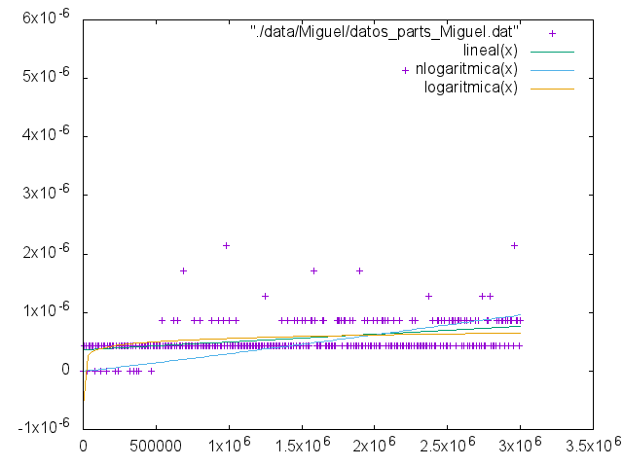
-Tabla y gŕafica de Diego(MacBook Pro,MacOS El Capitán):

Tamaño | Tiempo
1 | 2.34e-07
5001 | 6.35e-07
10001 | 6.9e-07
15001 | 5.58e-07
20001 | 5.28e-07
25001 | 6.74e-07
30001 | 5.33e-07
35001 | 5.96e-07
40001 | 7.28e-07
45001 | 6.3e-07
50001 | 5.86e-07
55001 | 6.07e-07
60001 | 8.7e-07
65001 | 7.1e-07
70001 | 8.5e-07
75001 | 8.11e-07
80001 | 6.72e-07
85001 | 8.74e-07
90001 | 6.72e-07
95001 | 6.14e-07
100001 | 1,04E-003
105001 | 8.95e-07
110001 | 7.66e-07
115001 | 8.16e-07
120001 | 6.03e-07
125001 | 8.28e-07
130001 | 8.11e-07
135001 | 9.06e-07
140001 | 8.57e-07
145001 | 1,07E-003
150001 | 1,11E-003
155001 | 7.15e-07
160001 | 8.27e-07
165001 | 7.7e-07
170001 | 1,16E-003
175001 | 9.08e-07
180001 | 1.31e-06
185001 | 1,74E-003
190001 | 7.88e-07
195001 | 7.76e-07
200001 | 1,02E-003
205001 | 7.02e-07
210001 | 8.63e-07
215001 | 9.41e-07
220001 | 8.99e-07
225001 | 1.33e-06
230001 | 1,38E-003
235001 | 9.95e-07
240001 | 1,03E-003
245001 | 9.44e-07
250001 | 9.38e-07
255001 | 8.46e-07
260001 | 8.86e-07
265001 | 1,18E-003
270001 | 9.37e-07
275001 | 1,14E-003
280001 | 1,23E-003
285001 | 9.73e-07
290001 | 9.31e-07
295001 | 9.39e-07
300001 | 1,32E-003
305001 | 8.88e-07
310001 | 1,24E-003
315001 | 9.73e-07
320001 | 1,13E-003
325001 | 1,34E-003
330001 | 9.59e-07
335001 | 1,22E-003
340001 | 1,26E-003
345001 | 1,55E-003
350001 | 1,10E-003
355001 | 1,36E-003
360001 | 1,18E-003
365001 | 1,04E-003
370001 | 1,04E-003
375001 | 9.46e-07
380001 | 1,31E-003
385001 | 1,55E-003
390001 | 1,11E-003
395001 | 1,24E-003
400001 | 1,27E-003
405001 | 1.38e-06
410001 | 1,03E-003
415001 | 1,33E-003
420001 | 1,20E-003
425001 | 1,20E-003
430001 | 1,40E-003
435001 | 1,10E-003
440001 | 1,11E-003
445001 | 1,36E-003
450001 | 1,20E-003
455001 | 1,35E-003
460001 | 1,45E-003
465001 | 1,25E-003
470001 | 1,05E-003
475001 | 1,30E-003
480001 | 1,31E-003
485001 | 9.73e-07
490001 | 1,36E-003
495001 | 1,14E-003
500001 | 1,25E-003
505001 | 1,35E-003
510001 | 1,42E-003
515001 | 9.46e-07
520001 | 1.59e-06
525001 | 1,14E-003
530001 | 1,26E-003
535001 | 1,31E-003
540001 | 1,33E-003
545001 | 1,18E-003
550001 | 1,20E-003
555001 | 1,34E-003
560001 | 1,18E-003
565001 | 1,46E-003
570001 | 2,94E-003
575001 | 1,20E-003
580001 | 1,10E-003
585001 | 1,47E-003
590001 | 1,20E-003
595001 | 1,13E-003
600001 | 1,50E-003
605001 | 1,51E-003
610001 | 9.87e-07
615001 | 1,14E-003
620001 | 1,47E-003
625001 | 1,28E-003
630001 | 1.27e-06
635001 | 1,46E-003
640001 | 1,40E-003
645001 | 1,48E-003
650001 | 1,63E-003
655001 | 1,34E-003
660001 | 1,44E-003
665001 | 1,81E-003
670001 | 1,11E-003
675001 | 1,25E-003
680001 | 1,93E-003
685001 | 1,39E-003
690001 | 1,50E-003
695001 | 1,79E-003
700001 | 1,36E-003
705001 | 2,19E-003
710001 | 1,52E-003
715001 | 1,08E-003
720001 | 1,11E-003
725001 | 1.14e-06
730001 | 1,02E-003
735001 | 1,08E-003
740001 | 1,35E-003
745001 | 1,02E-003
750001 | 1,11E-003
755001 | 1,55E-003
760001 | 1,37E-003
765001 | 1,36E-003
770001 | 1,80E-003
775001 | 1,66E-003
780001 | 1,48E-003
785001 | 1,54E-003
790001 | 1,49E-003
795001 | 1,38E-003
800001 | 1,39E-003
805001 | 1,29E-003
810001 | 1,58E-003
815001 | 1,28E-003
820001 | 1,34E-003
825001 | 1,55E-003
830001 | 1,63E-003
835001 | 1,45E-003
840001 | 1,76E-003
845001 | 1,82E-003
850001 | 1,25E-003
855001 | 1,96E-003
860001 | 1,35E-003
865001 | 1,24E-003
870001 | 1,65E-003
875001 | 1,31E-003
880001 | 1,21E-003
885001 | 1.32e-06
890001 | 1,52E-003
895001 | 1,42E-003
900001 | 1,46E-003
905001 | 1,47E-003
910001 | 1,77E-003
915001 | 1,12E-003
920001 | 1.45e-06
925001 | 1,31E-003
930001 | 1,17E-003
935001 | 1,40E-003
940001 | 1,44E-003
945001 | 1,52E-003
950001 | 1,42E-003
955001 | 1,92E-003
960001 | 1,23E-003
965001 | 1,85E-003
970001 | 2,57E-003
975001 | 1.23e-06
980001 | 1.45e-06
985001 | 1,51E-003
990001 | 1,09E-003
995001 | 1,35E-003
1000001 | 1,31E-003

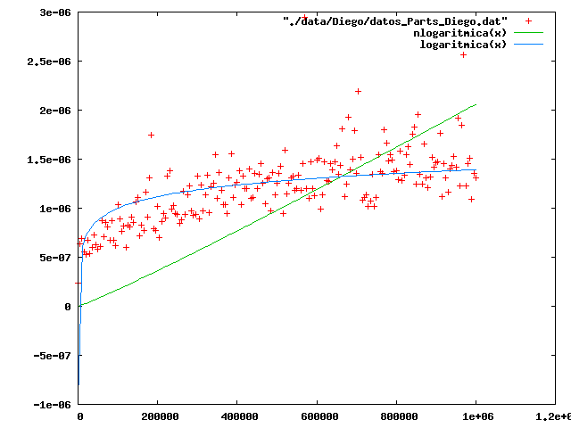

1.1 Comparación entre algoritmos

Para la comparación nos valdremos de la función logarítmica que hemos ajustado para la primera y la segunda solución DyV planteadas en la resolución del problema.

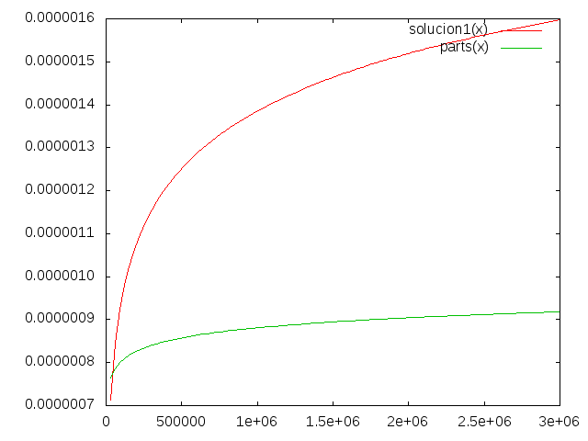
Como se puede observar en la gráfica la primera opción propuesta es menos eficiente que la segunda ya que la función ajustada y evaluada en el mismo rango de puntos perteneciente al primer algoritmo crece más rápido que la función ajustada para el segundo algoritmo.

1. Comparación de preferencias

El problema en este caso consiste en contar el número de inversiones que se producen en un vector considerándose como inversión que v[i]>v[j] con i<j.

1.1 Algoritmo Evidente

Comenzamos presentando el código del algoritmo:

#include <iostream>
using namespace std;
#include <ctime>
#include <cstdlib>
#include <climits>
#include <cassert>
#include <chrono>

double uniforme()
{
int t = rand();
double f = ((double)RAND_MAX+1.0);
return (double)t/f;
}

int CuentaIntercambios(int* v, int tam)
{
int inter=0;
for(int i=0;i<tam;i++)
{
for(int j = i; j < tam;j++)
{
if(v[j]<v[i])
{
inter++;
}
}
}
return inter;
}

using namespace std::chrono;

int main(int argc, char * argv[])
{
high_resolution_clock::time_point t1, t2;

if (argc != 2)
{
cerr << "Formato " << argv[0] << " <num_elem>" << endl;
return -1;
}

int n = atoi(argv[1]);

int * T = new int[n];
assert(T);

srand(time(0));

for (int j=0; j<n; j++) T[j]=j;
for (int j=n-1; j>0; j--) {
double u=uniforme();
int k=(int)(j*u);
int tmp=T[j];
T[j]=T[k];
T[k]=tmp;
}
for (int j=0; j<n; j++) {cout << T[j] << " ";}
cout << endl;

t1=high_resolution_clock::now();
int valor = CuentaIntercambios(T,n);
t2=high_resolution_clock::now();
duration<double> transcurrido = duration_cast<duration<double> >(t2-t1);
cout << "El número de inversiones es: " << valor << endl;
cout << n << " " << transcurrido.count() << endl;

}

El algoritmo consiste en recorrer para cada uno de los índices el resto del vector comprobando si se produce la condición de inversión definida en el enunciado del ejercicio.

Presentamos aquí las tablas y gráficas:

Datos:
-Tabla y gŕafica de Nacho(Toshiba,Linux):

Tamaño | Tiempo
1 | 1.41e-07
101 | 2.5142e-05
201 | 0.000103164
301 | 0.000193621
401 | 0.000337938
501 | 0.000477668
601 | 0.000679365
701 | 0.000924468
801 | 0.00117381
901 | 0.00149671
1001 | 0.00183842
1101 | 0.00227849
1201 | 0.00257789
1301 | 0.00297941
1401 | 0.00351359
1501 | 0.00404629
1601 | 0.00475955
1701 | 0.00514748
1801 | 0.00579727
1901 | 0.00647466
2001 | 0.00720559
2101 | 0.00795875
2201 | 0.020742
2301 | 0.0100898
2401 | 0.0103839
2501 | 0.0112249
2601 | 0.0124864
2701 | 0.0135843
2801 | 0.025158
2901 | 0.0188092
3001 | 0.0166604
3101 | 0.0176471
3201 | 0.0190568
3301 | 0.0203796
3401 | 0.0214306
3501 | 0.0231602
3601 | 0.0247035
3701 | 0.0338897
3801 | 0.0402618
3901 | 0.0296734
4001 | 0.0305172
4101 | 0.0322395
4201 | 0.0344103
4301 | 0.0362872
4401 | 0.0385013
4501 | 0.0404516
4601 | 0.0419227
4701 | 0.0438269
4801 | 0.0496024
4901 | 0.0476108
5001 | 0.0497908
5101 | 0.0528444
5201 | 0.0555525
5301 | 0.0586841
5401 | 0.059652
5501 | 0.0640451
5601 | 0.0654455
5701 | 0.0677321
5801 | 0.0714792
5901 | 0.0759207
6001 | 0.0761982
6101 | 0.0802454
6201 | 0.0823885
6301 | 0.084693
6401 | 0.0887807
6501 | 0.0920634
6601 | 0.0942812
6701 | 0.096847
6801 | 0.101346
6901 | 0.104578
7001 | 0.1119
7101 | 0.110501
7201 | 0.11544
7301 | 0.122986
7401 | 0.123559
7501 | 0.1298
7601 | 0.129741
7701 | 0.139224
7801 | 0.141131
7901 | 0.144716
8001 | 0.146903
8101 | 0.156615
8201 | 0.153374
8301 | 0.160559
8401 | 0.165401
8501 | 0.165359
8601 | 0.17228
8701 | 0.177866
8801 | 0.182278
8901 | 0.185653
9001 | 0.19154
9101 | 0.194373
9201 | 0.198858
9301 | 0.204216
9401 | 0.206225
9501 | 0.212323
9601 | 0.214682
9701 | 0.222414
9801 | 0.225165
9901 | 0.23387
10001 | 0.237106
10101 | 0.244802
10201 | 0.254192
10301 | 0.251092
10401 | 0.25802
10501 | 0.267473
10601 | 0.271421
10701 | 0.279284
10801 | 0.27993
10901 | 0.291511
11001 | 0.292077
11101 | 0.304337
11201 | 0.307809
11301 | 0.309712
11401 | 0.313846
11501 | 0.325054
11601 | 0.339133
11701 | 0.336089
11801 | 0.339654
11901 | 0.344832
12001 | 0.351193
12101 | 0.362577
12201 | 0.369682
12301 | 0.372372
12401 | 0.380374
12501 | 0.395468
12601 | 0.395431
12701 | 0.406584
12801 | 0.407657
12901 | 0.417396
13001 | 0.418317
13101 | 0.425276
13201 | 0.4352
13301 | 0.440336
13401 | 0.449723
13501 | 0.460098
13601 | 0.463531
13701 | 0.485028
13801 | 0.47791
13901 | 0.484678
14001 | 0.497073
14101 | 0.500524
14201 | 0.509293
14301 | 0.51623
14401 | 0.524169
14501 | 0.532901
14601 | 0.54192
14701 | 0.551537
14801 | 0.550408
14901 | 0.57888
15001 | 0.572873

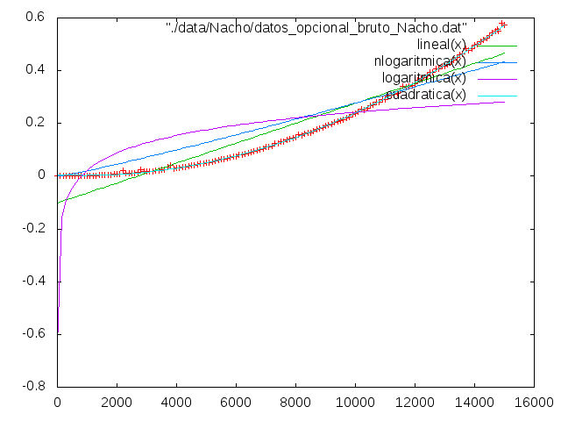
-Tabla y gŕafica de Luis(Fujitsu,Linux):

Tamaño | Tiempo
1 | 1.6e-07
101 | 2.8192e-05
201 | 0.000147707
301 | 0.000322543
401 | 0.00053221
501 | 0.000552182
601 | 0.00123978
701 | 0.00134266
801 | 0.00209974
901 | 0.00171646
1001 | 0.00327422
1101 | 0.00282971
1201 | 0.00479456
1301 | 0.00385254
1401 | 0.0063549
1501 | 0.00461788
1601 | 0.00851423
1701 | 0.00600093
1801 | 0.0102154
1901 | 0.00902456
2001 | 0.0126944
2101 | 0.00930031
2201 | 0.0117304
2301 | 0.0173308
2401 | 0.0126067
2501 | 0.0137294
2601 | 0.0223862
2701 | 0.0237495
2801 | 0.0182562
2901 | 0.0245377
3001 | 0.0194803
3101 | 0.0316626
3201 | 0.0241243
3301 | 0.0263231
3401 | 0.0405796
3501 | 0.0408961
3601 | 0.0434071
3701 | 0.0326005
3801 | 0.0348561
3901 | 0.0511171
4001 | 0.038446
4101 | 0.0574625
4201 | 0.0424753
4301 | 0.0653274
4401 | 0.0459118
4501 | 0.071764
4601 | 0.0514497
4701 | 0.0744898
4801 | 0.0817549
4901 | 0.0587425
5001 | 0.0626709
5101 | 0.0921241
5201 | 0.0679305
5301 | 0.0701484
5401 | 0.104526
5501 | 0.0770722
5601 | 0.118059
5701 | 0.0827904
5801 | 0.1247
5901 | 0.0901978
6001 | 0.131915
6101 | 0.096525
6201 | 0.141381
6301 | 0.103223
6401 | 0.153383
6501 | 0.110026
6601 | 0.114355
6701 | 0.166672
6801 | 0.125068
6901 | 0.176133
7001 | 0.188715
7101 | 0.134703
7201 | 0.14033
7301 | 0.186037
7401 | 0.149493
7501 | 0.15267
7601 | 0.15829
7701 | 0.207416
7801 | 0.162067
7901 | 0.164608
8001 | 0.168081
8101 | 0.169769
8201 | 0.17411
8301 | 0.178584
8401 | 0.182001
8501 | 0.189867
8601 | 0.19572
8701 | 0.198076
8801 | 0.201314
8901 | 0.207857
9001 | 0.274541
9101 | 0.21911
9201 | 0.285635
9301 | 0.228246
9401 | 0.284832
9501 | 0.283912
9601 | 0.241383
9701 | 0.250017
9801 | 0.255598
9901 | 0.259846
10001 | 0.266053
10101 | 0.274506
10201 | 0.278877
10301 | 0.28312
10401 | 0.300301
10501 | 0.298231
10601 | 0.302042
10701 | 0.308254
10801 | 0.319109
10901 | 0.320514
11001 | 0.325307
11101 | 0.332759
11201 | 0.340346
11301 | 0.344939
11401 | 0.353616
11501 | 0.358116
11601 | 0.364678
11701 | 0.374572
11801 | 0.382264
11901 | 0.385812
12001 | 0.396318
12101 | 0.465235
12201 | 0.411569
12301 | 0.417874
12401 | 0.428462
12501 | 0.428209
12601 | 0.436976
12701 | 0.443202
12801 | 0.450909
12901 | 0.523132
13001 | 0.467544
13101 | 0.480238
13201 | 0.490063
13301 | 0.498719
13401 | 0.508522
13501 | 0.544052
13601 | 0.511483
13701 | 0.523547
13801 | 0.526069
13901 | 0.537349
14001 | 0.545888
14101 | 0.554328
14201 | 0.566315
14301 | 0.568373
14401 | 0.583431
14501 | 0.586807
14601 | 0.596759
14701 | 0.607947
14801 | 0.614762
14901 | 0.694236
15001 | 0.628675

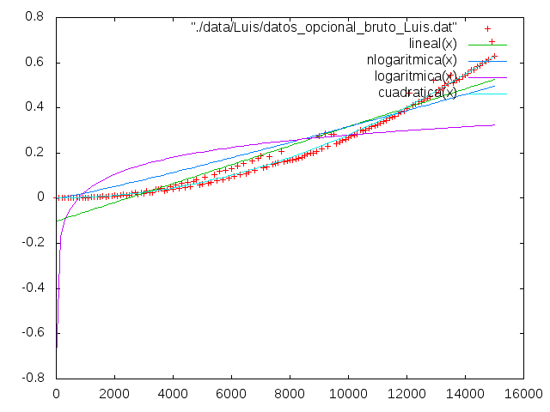

-Tabla y gŕafica de Miguel(Toshiba,Windows):

Tamaño | Tiempo
1 | 0,00E+000
101 | 3.67782e-005
201 | 0.000122309
301 | 0.000263007
401 | 0.000448181
501 | 0.000680397
601 | 0.00108923
701 | 0.00128382
801 | 0.00167298
901 | 0.00223235
1001 | 0.00203392
1101 | 0.0024928
1201 | 0.00282808
1301 | 0.00323862
1401 | 0.00437661
1501 | 0.00540255
1601 | 0.00660255
1701 | 0.00637504
1801 | 0.00623776
1901 | 0.0069776
2001 | 0.00758872
2101 | 0.00895422
2201 | 0.0092446
2301 | 0.0103625
2401 | 0.0112439
2501 | 0.0122912
2601 | 0.0132025
2701 | 0.0145749
2801 | 0.0156376
2901 | 0.0167773
3001 | 0.0184528
3101 | 0.0191743
3201 | 0.0207327
3301 | 0.0223107
3401 | 0.0237156
3501 | 0.026323
3601 | 0.0270577
3701 | 0.0295629
3801 | 0.0305324
3901 | 0.0322567
4001 | 0.0339574
4101 | 0.0367988
4201 | 0.0378812
4301 | 0.0399998
4401 | 0.0419067
4501 | 0.0441253
4601 | 0.0465185
4701 | 0.048676
4801 | 0.0513826
4901 | 0.0538066
5001 | 0.0562352
5101 | 0.0594589
5201 | 0.0603001
5301 | 0.0642956
5401 | 0.0663535
5501 | 0.0689973
5601 | 0.0768011
5701 | 0.074597
5801 | 0.0786721
5901 | 0.0815472
6001 | 0.0833562
6101 | 0.0867509
6201 | 0.0909479
6301 | 0.0935946
6401 | 0.0970287
6501 | 0.0999025
6601 | 0.103063
6701 | 0.108179
6801 | 0.111126
6901 | 0.115683
7001 | 0.118745
7101 | 0.124004
7201 | 0.128034
7301 | 0.128575
7401 | 0.133427
7501 | 0.137148
7601 | 0.141877
7701 | 0.148047
7801 | 0.149696
7901 | 0.154056
8001 | 0.163493
8101 | 0.167353
8201 | 0.168372
8301 | 0.17404
8401 | 0.176776
8501 | 0.184241
8601 | 0.188044
8701 | 0.190724
8801 | 0.194922
8901 | 0.199271
9001 | 0.204697
9101 | 0.210242
9201 | 0.216967
9301 | 0.221377
9401 | 0.2274
9501 | 0.23417
9601 | 0.241249
9701 | 0.243229
9801 | 0.247843
9901 | 0.254906
10001 | 0.260722
10101 | 0.2641
10201 | 0.280373
10301 | 0.284467
10401 | 0.283322
10501 | 0.288508
10601 | 0.296735
10701 | 0.297905
10801 | 0.306541
10901 | 0.316452
11001 | 0.318094
11101 | 0.3293
11201 | 0.330299
11301 | 0.337074
11401 | 0.341459
11501 | 0.355528
11601 | 0.363275
11701 | 0.373213
11801 | 0.370941
11901 | 0.376231
12001 | 0.384004
12101 | 0.389432
12201 | 0.40455
12301 | 0.411544
12401 | 0.411578
12501 | 0.422784
12601 | 0.425359
12701 | 0.439993
12801 | 0.441992
12901 | 0.464003
13001 | 0.455155
13101 | 0.463763
13201 | 0.481056
13301 | 0.480865
13401 | 0.495515
13501 | 0.504993
13601 | 0.509312
13701 | 0.518555
13801 | 0.512743
13901 | 0.53797
14001 | 0.535575
14101 | 0.549034
14201 | 0.557956
14301 | 0.564806
14401 | 0.562542
14501 | 0.575398
14601 | 0.583573
14701 | 0.607203
14801 | 0.62391
14901 | 0.622479
15001 | 0.626356

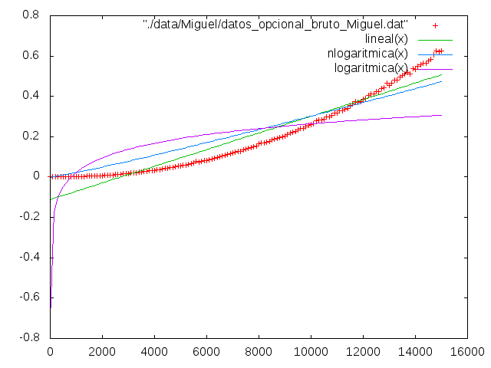
-Tabla y gŕafica de Diego(MacBook Pro,MacOS El Capitán):

Tamaño | Tiempo
1 | 2.25e-07
101 | 2.4302e-05
201 | 8.1735e-05
301 | 0.000170414
401 | 0.000296484
501 | 0.000451955
601 | 0.000644197
701 | 0.000863413
801 | 0.00113277
901 | 0.00137309
1001 | 0.00172884
1101 | 0.00208632
1201 | 0.00247088
1301 | 0.00295514
1401 | 0.0033287
1501 | 0.00388584
1601 | 0.0043908
1701 | 0.00503627
1801 | 0.00566275
1901 | 0.00629676
2001 | 0.00807377
2101 | 0.00797816
2201 | 0.00862705
2301 | 0.0095215
2401 | 0.0103179
2501 | 0.0113802
2601 | 0.0121125
2701 | 0.0134044
2801 | 0.0143518
2901 | 0.0155613
3001 | 0.0187058
3101 | 0.0182389
3201 | 0.0213527
3301 | 0.0210211
3401 | 0.0222721
3501 | 0.0234907
3601 | 0.025179
3701 | 0.0266806
3801 | 0.02822
3901 | 0.0302005
4001 | 0.0322439
4101 | 0.033746
4201 | 0.0358188
4301 | 0.0377885
4401 | 0.0394659
4501 | 0.0420843
4601 | 0.0437907
4701 | 0.0459135
4801 | 0.0479473
4901 | 0.0501298
5001 | 0.052675
5101 | 0.0548173
5201 | 0.0586887
5301 | 0.0594106
5401 | 0.0621907
5501 | 0.0651138
5601 | 0.0692823
5701 | 0.0702256
5801 | 0.0723658
5901 | 0.0751053
6001 | 0.078383
6101 | 0.0811813
6201 | 0.0831296
6301 | 0.0864583
6401 | 0.0904768
6501 | 0.0928074
6601 | 0.0969403
6701 | 0.100301
6801 | 0.104771
6901 | 0.10637
7001 | 0.109353
7101 | 0.112116
7201 | 0.116381
7301 | 0.119558
7401 | 0.123646
7501 | 0.12981
7601 | 0.132739
7701 | 0.136115
7801 | 0.137682
7901 | 0.142392
8001 | 0.145664
8101 | 0.150156
8201 | 0.152686
8301 | 0.159602
8401 | 0.162112
8501 | 0.16568
8601 | 0.172043
8701 | 0.173587
8801 | 0.179724
8901 | 0.183676
9001 | 0.189255
9101 | 0.19117
9201 | 0.195654
9301 | 0.200319
9401 | 0.204126
9501 | 0.209585
9601 | 0.216573
9701 | 0.22744
9801 | 0.225042
9901 | 0.228409
10001 | 0.233405
10101 | 0.238596
10201 | 0.242865
10301 | 0.248328
10401 | 0.254965
10501 | 0.263621
10601 | 0.261818
10701 | 0.274417
10801 | 0.272946
10901 | 0.279434
11001 | 0.28821
11101 | 0.292327
11201 | 0.297448
11301 | 0.301413
11401 | 0.306507
11501 | 0.313108
11601 | 0.322264
11701 | 0.331253
11801 | 0.330332
11901 | 0.343929
12001 | 0.354204
12101 | 0.350988
12201 | 0.356959
12301 | 0.362727
12401 | 0.371634
12501 | 0.378877
12601 | 0.387432
12701 | 0.38903
12801 | 0.396997
12901 | 0.402902
13001 | 0.412632
13101 | 0.414524
13201 | 0.419921
13301 | 0.42725
13401 | 0.432129
13501 | 0.463131
13601 | 0.448017
13701 | 0.455221
13801 | 0.468799
13901 | 0.473549
14001 | 0.47229
14101 | 0.48199
14201 | 0.497067
14301 | 0.503074
14401 | 0.509881
14501 | 0.51028
14601 | 0.531013
14701 | 0.528305
14801 | 0.532981
14901 | 0.544032
15001 | 0.552598

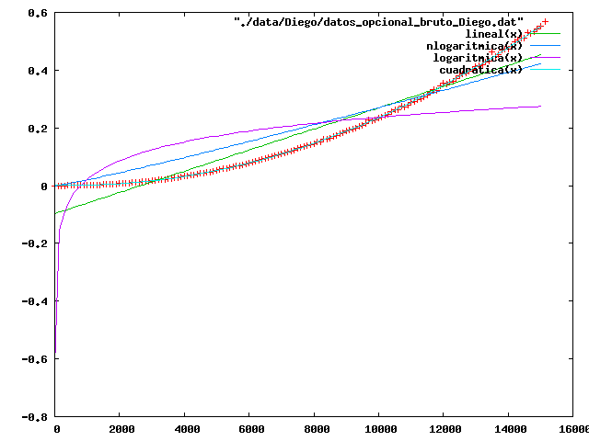
1.1 Solución DyV

Para la solución propuesta en el ejercicio siguiendo el patrón DyV hemos usado el código que teníamos de la primera práctica correspondiente al mergesort. Comenzamos presentando el código:

